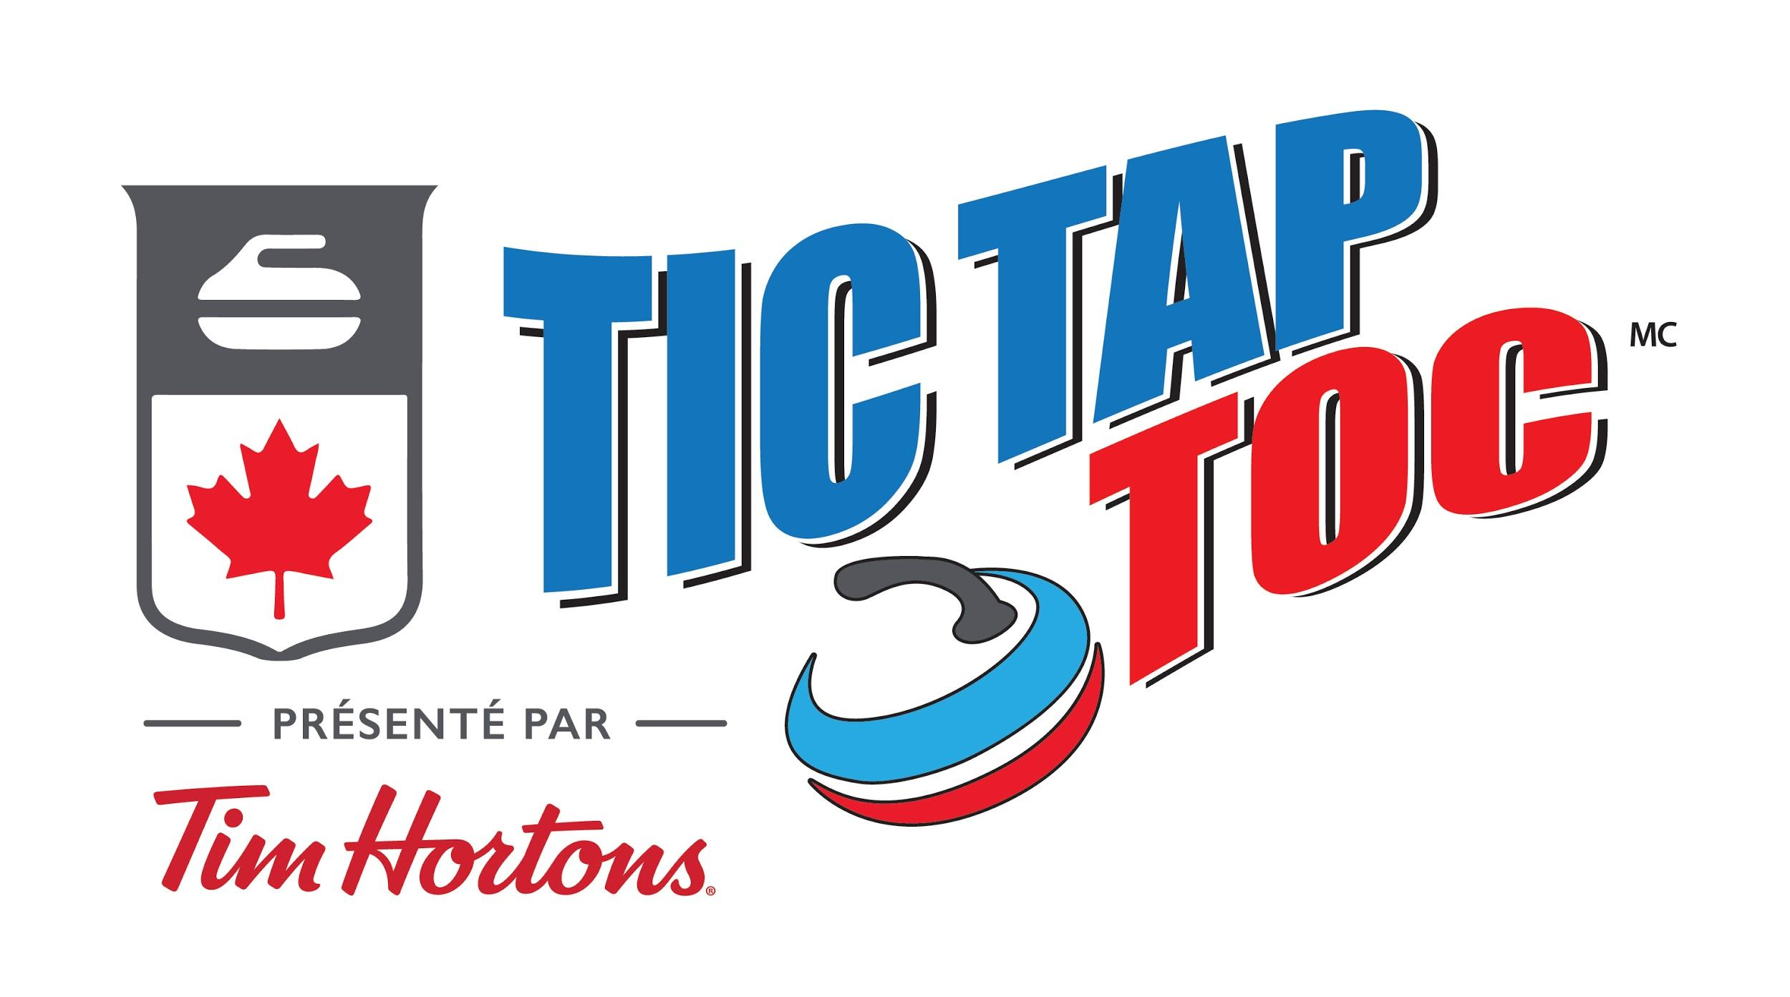

TIC, TAP & TOC
CLUB REGISTRATION FORM

CURLING CLUB : |  | Click or tap here to enter text.
ADDRESS : | Click or tap here to enter text.
TTT PROGRAM COORDINATOR : |  |  |  |  | Click or tap here to enter text.
EMAIL: | Click or tap here to enter text.
PHONE 1: | Click or tap here to enter text.
PHONE 2: | Click or tap here to enter text.
EVENT DATE: | Click or tap here to enter text.
# OF PARTICIPANTS : |  |  | Click or tap here to enter text.

- Club registration deadline is December 3, 2023. Deadline date for TTT activity in club is December 10, 2023.
- Results must be completed in the Excel document.

Please return your completed form to Aline Fellmann – afellmann@curling-quebec.qc.ca

