« A » Sponsor  Lake St-Louis  Trophy | « B » Sponsor  Lake of Two  Mountains  Trophy | « C » Sponsor  D’Urfé Cup  Trophy | « D » Sponsor  North Shore  Trophy | « E » Sponsor  Outaouak  Trophy | « F » Sponsor  Lakeshore  Trophy

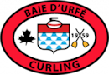
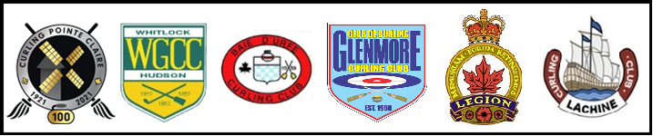
514-695-4324 | 450-458-5305 | 514-457-5900 | 514-684-6350 | 450-458-4882 | 514-637-9521

2023 LAKESHORE BONSPIEL

Mark these dates in your agenda now!

February 18-19 & 25-26

OPEN TO ALL
$200 per team

Register online at www.lakeshorebonspiel.ca
Registration Deadline – Friday January 27, 2023

- 4 games guaranteed
- 6 Divisions
  - Finals and Consolation Finals within each Division
  - Runners-up receive gift
- All participants receive commemorative pins
- Snack after every draw
- Brunch for finalists on Sunday, February 26th

FORMAT: Weekends Only
- Games 1 & 2: Saturday, February 18 | - Games 3 and/or 4: Sunday, February 19
Next game(s): Saturday, February 25
Semi-finals & Finals: Sunday, February 26

Questions / Info – Contact Host Lakeshore Representative

Pointe-Claire Curling club: Ben Brown @ (438) 881-5430 or

benbrown@royallepage.ca

