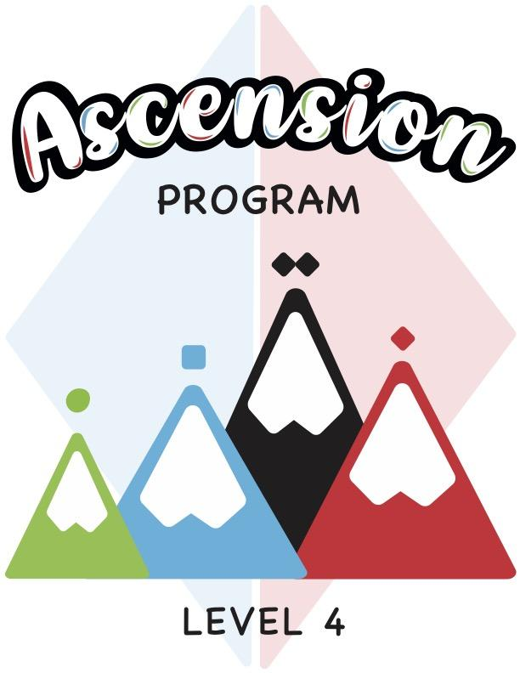

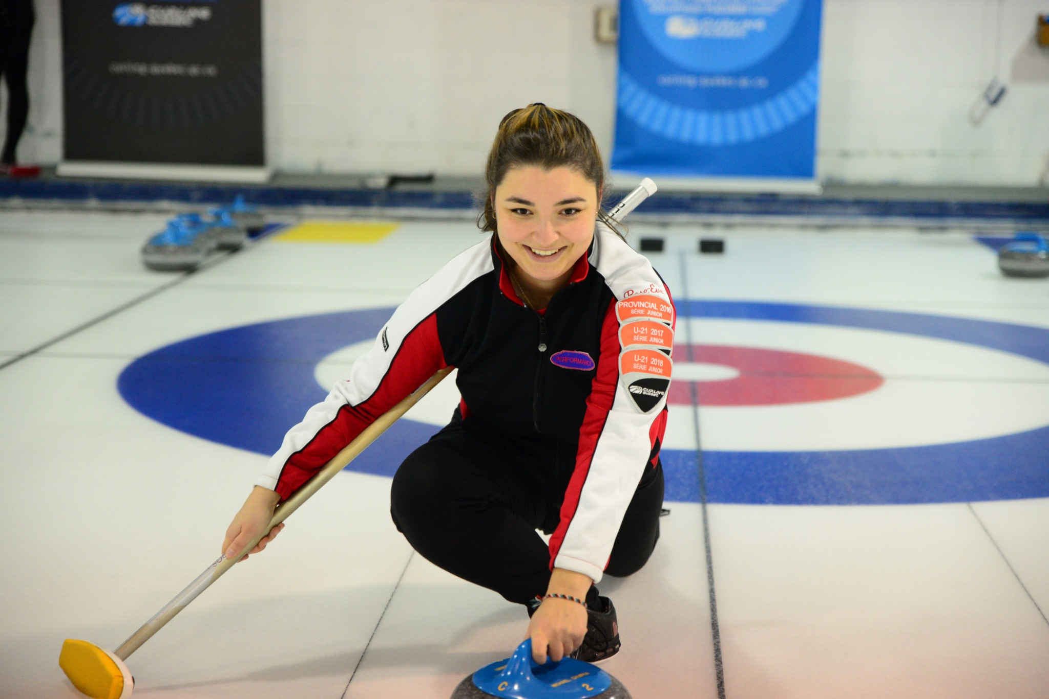
ABOUT ASCENSION

Ascension is a four-level program, with eight to ten weekly sessions per level. Each weekly training session is two hours long and is divided into three sections: off-ice learning session, on-ice learning session, and game play.

The program aims to teach the basic curling techniques and skills to adults. With this creative program, we want to offer a positive experience to all the participants in a safe and secure environment. We also offer a training session to the instructors who will be in charge of the program in each of their respective curling clubs.

The final goal is to have all participants reach an intermediate level of play which will help with member retention in each club offering the program.

In the novice level, participants will get to know the game as well as learn all of the curling terminology. Curlers will learn to sweep in the open position and will understand the reasons why it is important to sweep a stone. Players will also learn the starting position in the hack and how to complete a balanced slide with a stabilizer. The beginner level strategy aims to provide a general understanding of the basic game strategy with and without the hammer, and also teaches the participants the different types of shots and weights to select from.

Upon completion of the intermediate level, players will be able to sweep in both the open and closed positions and will understand the four key points to the sweeping position, know why to brush a stone and know how to communicate the speed of the stone to their team. Each curler will also be at ease with the starting position in the hack and will be able to execute a balanced slide using a broom, and will even be able to slide with their eyes closed. The intermediate-level strategy includes the basic strategy with and without the hammer, explains the different factors that influence the strategy choices, and teaches the differences between a defensive strategy, a cautious strategy and an offensive strategy. Players will also develop an understanding for adapting their game plan for the beginning, middle and end of the game.

After completing the advanced levels, each curler will be able to sweep with ease and will have a better understanding and better execution of the key points to the sweeping position, will master the footwork while sweeping and will be able to efficiently communicate the speed of the stone to their teammates. Participants will know how to correctly execute the recommended starting position in the hack, will be able to complete a balanced slide with or without a broom, and will be able to slide towards a target with their eyes closed, with or without a broom. The advanced-level strategy will master the different strategies based on the different game scenarios and will teach the participants how to adapt their strategies accordingly.

GENERAL RECOMMENDATIONS
- We strongly recommend holding a “club coach” clinic or a private training session for the instructors who will be teaching the classes. The private training session should be taught by someone who has their Competition-Introduction certification or higher. The goal for this workshop is to ensure that the instructors have a good understanding of the skills which will be taught throughout the course, and a general understanding of the program itself.

- This developmental league is geared towards a recreational level curler. The participants within each group will likely have many different skill levels and different physical abilities. We recommend that the instructors adapt the training sessions accordingly in order to maintain a safe environment at all times.

- In the event that an accident occurs during one of the sessions, the instructor must complete an accident report and send one copy to the club administrator(s) and one copy to Curling Quebec.

- We recommend that all instructors have their CPR/AED certification as an extra safety measure to be able to adequately respond to any accidents that may occur during the classes.

- Each class is divided into 4 sections (off-ice theory, on-ice training, game time as well as stretching). Each activity has a recommended time associated with it, but feel free to adapt the allotted time according to the number of participants, the ice availability or the skill level of the participants.

- If there are more than one group per level (more than 8 participants), we recommend dividing the players up by skill level so that the participants can all learn at a similar pace.

- For the beginner levels (1 and 2), we recommend rotating the players’ positions during the games so that they can get a feel for the different roles of each position. In the more advanced levels (3 and 4), we recommend that the instructors designate positions for each player based on their level of play.

- For the on-ice drills, especially for levels 1 and 2, the instructor or the participants should push the stones towards the side of the sheet after they have come to rest in order to prevent any accidents/collisions with the following stones. Only certain drills will require the stones to be left in play.

- It is recommended for the instructors to participate in the warm up, the stretching and the on-ice activities as a way of setting a good example for the participants.

- During the end-of-class stretching session, the instructors can also review everything that the participants have learnt up until that point.

- For more than one group per level, the club may decide to offer the program on multiple days of the week.

- It is recommended to increase the price of the course as the levels increase to account for the increased difficulty and to pay the instructors for their time.

Last but not least, don’t forget to have fun with the participants!

Table of contents
ABOUT ASCENSION 2
GENERAL RECOMMENDATIONS 4
SUMMARY 8
WEEK 1 - Review of the sliding technique 12
Goals 12
Off-ice session 12
Technical session on-ice 12
Game 14
Stretching session 15
WEEK 2 - Review of holding the rock and the release 16
Goals 16
Off-ice session 16
Technical session on-ice 16
Game 17
Stretching session 18
WEEK 3 - Sweeping 19
Goals 19
Off-ice session 19
Technical session on-ice 20
Game 20
Stretching session 21
WEEK 4 - Weight control/Stopwatch 22
Goals 22
Off-ice session 22
Technical session on-ice 23
Game 23
Stretching session 24
WEEK 5 - Communication and mental preparation 25
Goals 25
Off-ice session 25
Technical session on-ice 26
Game 27
Stretching session 28
WEEK 6 - Advanced strategy 29
Goals 29
Off-ice session 29
Technical session on-ice 30
Game 30
Stretching session 31
WEEK 7 - Tournaments 32
Goals 32
Off-ice session 32
Technical session on-ice 32
Game 33
Stretching session 34
WEEK 8 - Objectives/Nutrition/Training 35
Goals 35
Off-ice session 35
Technical session on-ice 36
Game 37
Stretching session 37
WEEK 9 - Review of techniques 39
Goals 39
Off-ice session 39
Technical session on-ice 39
Game 41
Stretching session 41
WEEK 10 - Special day Level 4 42
Goals 42
Off-ice session 42
Technical session on-ice 42
Game 43
Stretching session 43

SUMMARY - LEVEL 4

Week 1

Theme: Review of the sliding technique
Goals:
- Body alignment in the hack
- Steps to sliding
- Line of delivery

30 | 60 | 30

Week 2

Theme: Review of holding the rock and the release
Goals:
- Holding the rock
- Release zone
- Putting the finishing touches on the throwing routine

20 | 40 | 60

Week 3

Theme: Sweeping
Goals:
- Review the 4 key points
- Sweeping in the open and closed position
- Introduction to directional sweeping

30 | 30 | 60

Week 4

Theme: Weight control/Stopwatch
Goals:
- Pushing out of the hack with control
- Review of the eleven zones and signals for take-outs
- Understanding the use of a stopwatch

30 | 45 | 45

Week 5

Theme: Communication and mental preparation
Goals:
- Review of the roles of each player
- Improving team communication
- Introduction to mental preparation

45 | 15 | 60

Week 6

Theme: Advanced strategy
Goals:
- Review of the types of strategies and influencing factors
- Developing a strategic plan
- Understanding tolerance

45 | 15 | 60

Week 7

Theme: Tournaments

Goals:
- Preparation for tournaments
- Key factors to consider
- Colts Circuit and Club Championship

45 | 15 | 60

Week 8

Theme: Objectives/Nutrition/Training
Goals:
- Setting objectives
- Nutrition-hydration before, during and after the game
- Physical training and recovery

45 | 15 | 60

Week 9

Theme: Review of techniques
Goals:
- Review shot making techniques
- Review sweeping techniques
- Special team games

15 | 45 | 60

Week 10

Theme: Special day
Goals:
- Fun games!
- Global review of all the points seen during Level 4
- Program evaluation

10 | 10 | 100

Recommended time per session for the following sections
Off-ice technique | On-ice technique | Game played

Level 4 equipment needed

On-ice

- Grippers
- Sliders
- Stabilizers
- Brooms
- Orange soccer cones
- Empty tissue boxes
- Ball
- Stopwatches (1 to 2 per 4 participants)
- Rope to show the hitting angles
- Magnetic Board with different coloured magnets for strategy
- Gardening glove (end of index and thumb sewn together)
- Eye patch

Off-ice

- The participant guide or notepad
- Pens
- Plastic rock or Floor Curl kit
- Magnetic Board
- Magnets
- Dry eraser pens for the magnetic board
- Portable hack

WEEK 1 - Review of the sliding technique

Goals
- Body alignment in the hack
- Steps to the slide
- Line of delivery

Off-ice session (30 minutes)
10 minutes - Welcome
- Welcome the participants
- Introduction of the instructor(s)
- Introduction of the participants
5 minutes - Presentation of the program as a whole
- Presentation of the program as a whole (goals, duration of the program, duration of the sessions and themes for level 4).
10 minutes – Review of the safety measures
- The instructor asks questions about the terminology and reminds the participants about one-ice safety.
5 minutes - Warm-up session
- The instructor reminds participants about the importance of warming up before a sport (activating the body, increasing blood circulation and increasing the oxygen supply to the muscles).
- Choose four or five exercises and perform each one for about 30 to 45 seconds.
- The instructor leads the warm-up session.

Technical session on-ice (60 minutes)
10 minutes – Review of body alignment in the hack/holding the handle of the rock
- The instructor asks one of the participants to demonstrate proper alignment in the hack and the important elements to take into consideration: (position of the foot in the hack, starting position of the sliding foot, position of the hips and shoulders, position of the arm holding the rock and of the arm holding the broom).
- One of the participants explains how to hold the handle of the rock.
- The instructor asks the participants for their opinions or comments on each point, and asks if there should be corrections made to the positions.
10 minutes – Review of the stages of the slide
- The instructor asks another participant to demonstrate the stages of the slide and to also explain the different techniques used between a draw and a take-out (height of the hips, body movement, backing up, pause, forward motion, pushing from the hack).
- Different techniques between a draw and a take-out: for take-outs, one must move slightly further back in the backswing than for draws, transfer weight to the top of the body when moving forward and delay moving the sliding foot forward (rock-foot timing).
10 minutes – Drill #1: Practice balanced sliding towards a target
- The instructor sets up a few cones or targets anywhere on the playing surface.
- Participants attempt to slide towards each target with the correct pushing force (first without a rock, then with a rock).
20 minutes - Drill #2: All in the house
- The participants try to get as many rocks into the house as possible.
- A skip, a shot-maker and two sweepers for this drill. Rotate every two shots.
- Sweepers will communicate the speed of the shot using the eleven zone system and will sweep as needed to achieve the goal of reaching the house.
10 minutes - Drill #3: Introduction to the broomless slide (no stabilizer or broom)
- The instructor demonstrates a broomless slide. Participants should put their arms in an airplane position to help keep their balance. The goal is to perform a slide with a very slow push in order to be more stable and controlled during the slide.

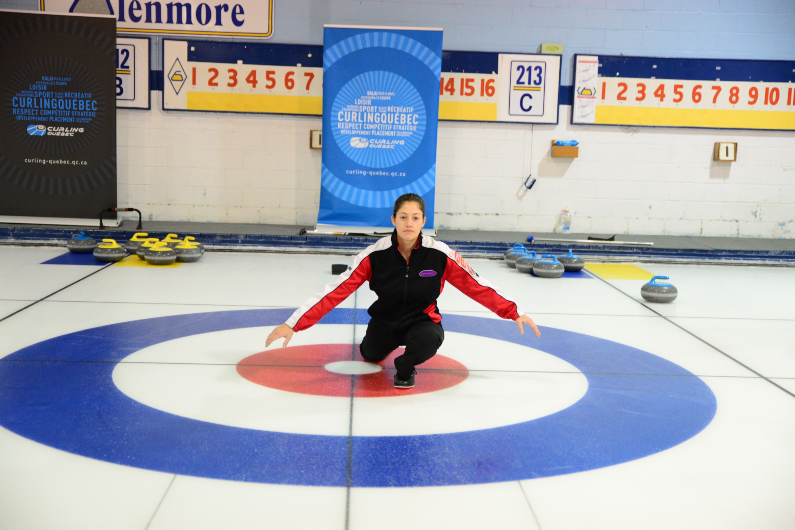
- This exercise will allow participants to improve their stability for all types of shots.

*For level 4, participants can use either a stabilizer or a broom when sliding depending on their comfort level. The instructor may recommend the stabilizer or the broom to the participants as needed to help them with their balance if they are uncomfortable while sliding.

Game (30 minutes)
Game #1 - 2 ends
- The instructor divides the participants into two teams per sheet.
- The instructor supervises the game and makes corrections to the position in the hack and to the stages of the slide.
- Ask each team to plan their strategy for each end (offensive, cautious, or defensive).
- Participants can use any type of shot for this game.
- At the end of each end, ask participants to count the points and post them on the scoreboard.
- The instructor validates with the participants whether the objectives of the strategy plan worked.

*The instructor concentrates on communication between participants for both ends.

Stretching session (5 minutes)
5 minutes – Stretching session
- The instructor reminds the participants of the importance of stretching after the sport (relaxing the body, reducing the heart and breathing rate, increasing recovery).
- Choose four or five stretches and hold each stretch for 30 to 45 seconds.
- The instructor leads the stretching session.

End of the session, thank the participants and announce the subjects that will be covered in the next session!

WEEK 2 - Review of holding the rock and the release

Goals
- Holding the rock
- Release zone
- Putting the finishing touches on the throwing routine

Off-ice session (20 minutes)
Review the points seen in last week’s session
5 minutes - Review the technical points for holding the rock and the release zone
- The instructor reviews the correct technique for holding the stone.
- The instructor also reminds participants about the importance of the release zone and when the rotation should begin.
10 minutes – Review the routine in the hack and its benefits
- Participants can review their routine they have written in their notebook and can mention the benefits associated with it. The instructor can supplement, if certain elements have not been mentioned.
5 minutes - Warm-up session
- The instructor asks the participants which muscle groups are used in curling.
- Choose four or five exercises and perform each one for 30 to 45 seconds.
- The instructor leads the warm-up session. The instructor throws a ball to a participant and calls their name, the participant must name a muscle group and a warm-up exercise to be performed by the group.

Technical session on-ice (40 minutes)
10 minutes – Slide with and without a broom
- The instructor places a target on the playing surface and each participant takes a few slides towards the target using a broom or a stabilizer .
- Once participants have warmed up, the instructor sets up the targets near the hog line and each participant attempts to slide without a broom or stabilizer while maintaining their balance. Participants can either use the airplane position or just a slide position as if they had a rock and a broom in their hands.
20 minutes – Drill #1: Reach the correct zone (1 to 6) while respecting the release zone (introduction of the gardener’s glove)
- A skip in the house, two sweepers and a player in the hack. Change positions after every two shots.
- The player in the hack must either roll a die or pick a number from 1 to 6. Depending on the number, the player must attempt to throw the rock in the correct zone (from guard to the top 4-foot) and the sweepers will have to judge and sweep the rock according to its speed.
- The instructor places two cones in the release zone to remind participants to start the spinning motion at the first cone and to release the rock at the second cone. Participants may mention the keywords “Tic Tac Toe” during the release.
- A modified gardening glove can be given to each participant (with the thumb and index finger sewn together). This way, the participant must absolutely let go of the rock at the 12 o’clock position.
10 minutes – Drill #2: Twin shots
- Each participant must attempt to make two identical shots while repeating their routine. The instructor can use cones or small magnets to indicate where the participant began the rotating motion and where they released their stone. We then compare the indicators with those of the second shot.
- Have one or two sweepers use stopwatches to time the rocks from the back line to the hog line in order to compare the times obtained between both shots.

Game (60 minutes)
Game #1 - 4 ends
- The instructor divides the participants into two teams per sheet.
- Ask each team to plan their strategy for each end (offensive, cautious or defensive).
- The instructor supervises the game and makes corrections to the participants’ releases and routines.
- Participants can use any type of shots for this game.
- At the end of each end, the participants count the points and post them on the scoreboard.

*Instructor focuses on sliding techniques and the release zone. The instructor may set up cones on the side of the sliding area to help participants achieve consistent releases.
**This activity can also be divided into two two-end games depending on the number of participants.

Stretching session (5 minutes)
5 minutes – Stretching session
- The instructor asks the participants which muscle groups are used in curling.
- Choose four or five stretches and hold each stretch for 30 to 45 seconds.
- The instructor leads the stretching session based on participants' responses. This stretching session can also be done in the same way as the warm-up session by throwing a ball to participants, calling their names, and having those participants name a stretch. This is also a good way to learn the participants’ names.

End of the session, thank the participants and announce the subjects that will be covered in the next session!

WEEK 3 - Sweeping

Goals

- Review of the 4 key points
- Sweeping in the open and closed positions
- Introduction to directional sweeping

Off-ice session (30 minutes)
Review of the points seen in last week’s session
5 minutes - Review of the four key points for effective sweeping
- With the help of the participants, the instructor reviews the four key points for effective sweeping as well as the factors that can influence the path of a rock.
5 minutes – Sweeping review in open position vs closed position
- The instructor can have two participants do an off-ice demonstration of the open and closed position. The two participants should mention the technical differences between the two positions. The group and the instructor can complete as needed.
15 minutes - Introduction to directional sweeping
- The instructor talks about directional sweeping and how it should be used in order to be effective.
- Discussion regarding the "broom gate" that took place in 2016 and the broom head fabrics that are now mandatory for use in competition.
- Regardless of the level of play, it is important to understand that directional sweeping has little impact on the path of the rock.
5 minutes - Warm-up session
- Choose four or five exercises and perform each one for about 30 to 45 seconds.
- The instructor leads the warm-up session.
- Make sure to adequately warm-up the upper body as the participants will practice the various sweeping techniques during this session.

Technical session on-ice (30 minutes)
15 minutes – Drill #1 : Different sweeping techniques
- The instructor divides the participants into two groups and asks them to line up, single file on each side of the 4 foot lines. The left group gets in the open sweeping position while the right group takes the closed sweeping position. At the instructor's signal, participants should sweep on the 4-foot line making sure they have proper posture with the four key points.
- The instructor has this drill done in intervals: 10 seconds of sweeping, 5 seconds of rest, 5 seconds of sweeping, 5 seconds of rest and finally another 10 seconds of sweeping (participants move towards the opposite house while sweeping, but do not move during the rest periods).
- Once the participants have reached the opposite end of the sheet, the group that was in the open sweeping position moves into the closed position and vice versa. The drill is repeated back towards the other end of the sheet.
- Once the round trip is complete, each participant takes a rock and the instructor demonstrates directional brushing. It is important to mention that at this level of play, directional sweeping does not have a big impact.
- Each participant can try directionally sweeping in front of their stone, without walking.
15 minutes – Drill #2: The sweeping challenge against the shot maker
- The instructor forms groups of two.
- The goal for the shooter is to draw into the house (one point for the shooter if the rock ends up in the house).
- The goal for the sweeper is to judge and sweep the rock if necessary so that it does not stop in the house (one point for the sweeper if the rock does not end up in the house).
- Teams alternate shooting and sweeping. The first player to reach three points wins the challenge.

Game (60 minutes)
Game #1 - 4 ends
- The instructor divides the participants into two teams per sheet.
- Ask each team to plan their strategy for each end (offensive, cautious or defensive).
- The instructor supervises the game and makes corrections to sweeping techniques and directional brushing.
- Participants can use any type of shots for this game.
- At the end of each end, the participants count the points and post them on the scoreboard.

*The instructor focuses on the participants’ sweeping techniques.
**This activity can also be divided into two 2-end games depending on the number of participants.

Stretching session (5 minutes)
5 minutes – Stretching session
- Choose three or four stretches and hold each stretch for 30 to 45 seconds.
- The instructor leads the stretching session and has each stretch done in three progressive steps.
- Have participants stretch a muscle and hold the position for 30 seconds. Take several deep breaths. After 30 seconds, exhale and go slightly further into the stretch and hold for 15 seconds. Take several more deep breaths. After 30 seconds, exhale and go slightly further into the stretch and hold for a final 15 seconds.

*Be careful never to inflict pain. Each participant must stretch according to their own abilities.

End of the session, thank the participants and announce the subjects that will be covered in the next session!

WEEK 4 - Weight control/Stopwatch

Objectifs
- Pushing out of the hack with control
- Reviewing the 11 zones and the signals for take-outs
- Understanding how to use a stopwatch

Off-ice session (30 minutes)
Review of the points seen in last week’s session
10 minutes - Review of the 11 zones and the signal system for take-outs
- With the help of the participants, the instructor reviews the eleven zones for guards and draws.
- The instructor reviews the signal system (or creates a new system) with the participants for calling different types of take-outs.
15 minutes – Review of the use of the stopwatch and the different timing techniques
- The instructor should have a few stopwatches for the participants to use to improve their skills with this reference tool.
- The instructor explains the different ways of timing stones depending on the requested speed for the shot.
- It is important to remember that the stopwatch does not always give a reliable measurement depending on the way the stone was released. It is important to develop an "eye" for effective judgment and to remember the different factors that can influence the speed of a rock.
5 minutes - Warm-up session
- Choose four or five exercises and perform each one for about 30 to 45 seconds.
- The instructor leads the warm-up session and can demonstrate one or two dynamic stretching exercises. Example: walking lunges (forwards or backwards) to reproduce the sliding motion, or side-stepping while squatting to reproduce the footwork used while sweeping in the open position.

*Dynamic stretches are controlled movements that bring the muscles near their maximum stretch without exceeding their limit. They prepare the muscles for an activity.

Technical session on-ice (45 minutes)
15 minutes – Drill #1: Controlling the push from the hack (without and with a rock)
- The instructor sets up objects at different positions along the length of the sheet.
- Participants should complete balanced slides toward each object without sliding past them. They must therefore control the strength of their push from the hack.
- Repeat the drill with a rock without releasing it.
15 minutes – Drill #2: Catch me if you can
- The instructor divides the participants into two teams per sheet.
- A skip, a shooter and two sweepers for each shot. Team A begins by throwing a rock to any place in the playing area. A player from Team B must then repeat the shot with similar weight (the rock must come to rest within a maximum of two broom lengths from Team A’s rock to score a point).
- The teams alternate shooting.
- Participants can use a stopwatch to get a feel for the speed of the ice. The first team to reach four points wins the challenge.
15 minutes – Drill #3: The ladder game
- All participants are on the same team.
- A skip, a shooter and two sweepers. Rotate after each throw.
- The goal is to successfully throw a rock into each of the eleven zones in either ascending or descending order (example: the first shooter aims for zone 11, the second shooter aims for zone 10 and so on or the first shooter aims for zone 1, the second shooter aims for zone 2, etc.).
- When each rock finishes its course, move it to the side of the sheet in line with where it stopped.
- One point per successful throw. Try to achieve a result of 4 or 5 points out of 8 rocks.

*Depending on the number of participants and the number of sheets available, three stations can be made and each group rotates every 15 minutes.

Game (45 minutes)
Game #1 - 3 ends
- The instructor divides the participants into two teams per sheet and hangs a score on each sheet’s scoreboard (example: Sheet A: We are in the 5th end, red team leads by two points but does not have the hammer or Sheet B: first end, yellow team has the hammer).
- Ask each team to plan their strategy for each end.
- The instructor supervises the game and helps the participants to use their stopwatches as well as to judge the rocks according to the eleven zones and the communication established with the signal system.
- Participants can use any type of shot for this game.
- At the end of each end, the participants count the points and post them on the scoreboard.

*The instructor encourages participants to communicate during the game.

Stretching session (5 minutes)
5 minutes – Stretching session
- The instructor asks participants to name some stretches or yoga positions that can help the body recover and relax after curling.
- Choose three or four stretches and hold each position for 30 to 45 seconds.
- Participants lead the stretching session with the supervision of the instructor.

End of the session, thank the participants and announce the subjects that will be covered in the next session!

WEEK 5 - Communication and mental preparation

Goals
- Reviewing the roles of each player
- Improving team communication
- Introduction to mental preparation

Off-ice session (60 minutes)
Review of the points seen in last week’s session
20 minutes – Review of the roles of each player
- Divide participants into five groups. Each group should name the roles for the position they have been assigned (example: Group A - name the roles of the lead).
- Add the roles of the coach… (Five groups).
- The instructor can complete the list of roles, if some points have been missed.
10 minutes - Improving team communication
- The instructor gives the participants some tips to improve team communication during the game.
25 minutes - Introduction to mental preparation
- The instructor begins to discuss mental preparation with the participants, a very important aspect in the practice of all sports and in everyday life.
- The instructor then asks participants to name any distractions that may arise during play or competition. The instructor completes with some examples.
- Mental Preparation Video: The goal for participants is to count how many times the players wearing white shirts pass the basketball.
Selective Attention Test: https://www.youtube.com/watch?v=vJG698U2Mvo *Stop the video at 36 seconds.
- Once the video is finished, the instructor asks the participants how many throws they counted. The instructor then asks the following questions: How many elevator doors were there, what were the letters on the wall, and was there anything else? Show the rest of the video.
- The goal of the drill is to be successful by only focusing on the number of passes made by the team wearing white shirts. If participants succeeded in counting or seeing anything else, it means they were distracted.
- Mental focus is funneling your attention to focus only on the goal at hand while putting other distractions aside.
5 minutes - Warm-up session - The ball game
- The group should sit down to form a large circle (maximum 12 participants per circle).
- The instructor has three balls in their hands (tennis balls or stress balls). Begin by throwing one ball to a participant. Then the participant will throw the ball to another participant and so on until the ball returns to the instructor. (Always throw to the same person and receive from the same person.) After two or three rounds the instructor adds a second ball into play and eventually adds a third ball. The goal is to complete as many rounds as possible without dropping any of the balls.
- This exercise will help participants improve their concentration and pay attention to the task at hand.

Technical session on-ice (30 minutes)
5 minutes – Slides with and without a broom (or stabilizer)
- Each participant takes a few slides with their broom or their stabilizer towards a target that the instructor will have placed on the playing surface.
- Once participants have warmed up, the instructor sets up the targets near the hog line and each participant attempts to slide without a broom or stabilizer while keeping their balance. Participants can use the airplane position or the sliding position as if they had a rock and a broom.
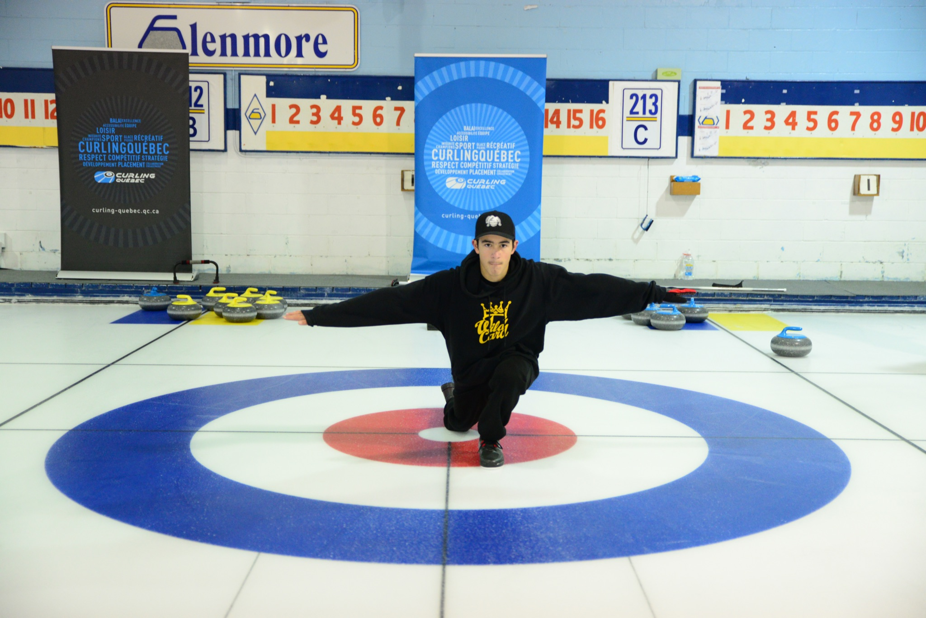
10 minutes – Drill #1: Dealing with distractions
- A skip, two sweepers, a shooter. Rotate after each shot.
- Participants attempt to execute various shots requested by the skip while managing the distractions. They need to stay focused on the skip's broom while pushing out of the hack with the right speed.
- During some shots, the instructor will cause a distraction such as dropping their broom near the shooter, talking with another player or moving behind the skip.
- By performing their routine, participants will have a better chance of staying focused while shooting.
15 minutes - Drill #2: One end of curling without talking
- Divide the participants into two teams per sheet.
- The instructor plays loud music on the ice (if possible), or simply instructs participants not to speak during the end.
- Participants will be able to discuss their strategic plan before starting the end, but from the first rock on, the two teams should communicate only by signs.
- After the end, discuss the drill with the participants to see how the teams adapted to playing silently and to see if the mode of communication was modified throughout the exercise.
- This drill allows participants to adapt to a common distraction which could happen during a game, if the team has difficulty hearing each other on the ice.

Game (60 minutes)
15 minutes - Last stone draw (shootout)
- The instructor divides the participants into two teams per sheet.
- The participants each take a few practice slides without rocks.
- Each participant throws a practice shot towards the away end, and another practice shot towards the home end.
- In turn, each participant throws a precision shot with a skip and two sweepers.
- The team with the best result will have the last rock advantage in the first end of the game.
- Points: button completely hidden = 5 points, touching on the button = 4 points, 4 foot = 3 points, 8 foot = 2 points, 12 foot = 1 point, outside the house = no point).

Game #1 - 3 ends
- Ask each team to come up with a strategic plan for each end.
- The instructor supervises the game and helps the participants with the use of the stopwatch as well as with the judging of the rocks according to the eleven zones and the communication established with the sign system.
- Participants can use any type of shot for this game.
- At the end of each end, the participants count the points and post them on the scoreboard.

*The instructor emphasizes participants’ communication during this game.

Stretching session (5 minutes)
5 minutes - Stretching session
- Choose three or four stretches and hold the position each for 30 to 45 seconds.
- The instructor leads the stretching session.
- For the last exercise, ask participants to lie on their backs or sit in a comfortable position with their eyes closed (you can play relaxing music).
- The instructor asks participants to place both hands on their stomachs and breathe-in for 5 seconds. Participants should feel their hands go up. Hold the position for 5 seconds. Exhale for 5 seconds, gently blowing air through your mouth. Finally, hold the position for another 5 seconds. Repeat 3 or 4 times.

End of the session, thank the participants and announce the theme for the next session!

WEEK 6 - Advance strategy

Goals
- Review of the types of strategies and influencing factors
- Developing a strategic plan
- Understanding tolerance

Off-ice session (45 minutes)
Review the points seen in last week’s session
10 minutes - Review of different types of strategies and influencing factors
- With the help of the participants, the instructor reviews the different types of strategies and the factors that can influence our decisions on each shot.
- For each factor, the instructor can mention how the strategy or the shot might have an impact.
Example: last end, last rock, the skip has the choice to make a draw into the 4-foot zone or to take an opponent's rock out in the 8-foot zone while remaining in the house to score the point. What will be the best strategy? What are the factors to consider? (ice speed, last end, ice reading, etc.).
20 minutes – Developing a strategic plan
- The instructor divides the participants into three groups and gives each of them a scenario for an end (example: mid-game, your team leads by 1 point and you don't have the hammer in the 5th end) Each team should discuss the style of play they would like to play and the strategic plan to adopt.
- We can have each team demonstrate the scenario on a magnetic board.
10 minutes - Review of the shot tolerance
- The instructor reiterates the importance of tolerance for each shot and gives examples to participants. The participants will try to give the right tolerance according to different factors to be taken into account during an end.
5 minutes - Warm-up session
- Choose four to five exercises and perform each for about 30 to 45 seconds.
- The instructor leads the warm-up session.
- The instructor or one of the participants can put on music during the warm-up sessions to help the group activate.

Technical session on-ice (15 minutes)
5 minutes – Practice sliding with and without a broom (or stabilizer)
- Each participant takes a few slides with their broom or their stabilizer towards a target that the instructor will have placed on the ice.
- Once participants have warmed up, the instructor sets up the targets near the hog line and each participant attempts to slide without a broom or stabilizer while maintaining their balance. Participants can assume the airplane position or the slide position as if they had a rock and a broom.
- For participants who feel comfortable, you can progress the exercise by sliding with a broom (or stabilizer) and closing their eyes once they have positioned themself in the hack.
10 minutes - Drill #1: The surprise strategy
- Three participants stand around the house with one rock of each color in hand (you can also do this drill with four participants, and eight stones).
- At the signal, each participant pushes one rock towards the center of the house. A scenario will therefore be created.
- The instructor provides the participants with a scenario (example: last end and last stone of the game).
- The instructor discusses the possible play options with the participants and also discusses the consequences (risk vs reward) according to the participants’ strategic decisions.
- If a yellow stone is shot rock, we must put ourselves in the red team’s shoes.
- Repeat this drill a few times in order to create several new game situations.

Game (60 minutes)
Game #1 - 4 ends
- The instructor divides the participants into two teams per sheet and posts a different score on each sheet’s scoreboard.
- Ask each team to establish a strategic plan for the game and for each end.
- The instructor supervises the game and can ask questions to the participants when they are in the inactive position in order to validate if each one knows the plan. You can also ask the skip what type of weight would be most appropriate depending on the desired result.
- Participants can use any type of shot for this game.
- At the end of each end, the participants count the points and post them on the scoreboard.

*The instructor focuses on strategy and makes sure participants are using the right tactics according to their plan for the end.
**We can also play two games of two ends depending on the number of participants.

Stretching session (5 minutes)
5 minutes - Stretching session
- Choose three or four stretches and hold each position for 30 to 45 seconds.
- The instructor leads the stretching session.
- For the last exercise, ask participants to lie on their backs or sit in a comfortable position with their eyes closed (you can play relaxing music).
- The instructor asks participants to place both hands on their stomachs and breathe-in for 5 seconds. Participants should feel their hands rise. Hold the position for 5 seconds. Exhale for 5 seconds, gently blowing air through your mouth. Finally, hold the position for another 5 seconds. Repeat 3-4 times.

End of the session, thank the participants and announce the theme for the next session!

WEEK 7 - Tournaments

Goals
- Preparation for tournaments
- Key factors to consider
- Colts Circuit and Club Championships

Off-ice session (45 minutes)
Review the points seen in last week’s session
25 minutes - Tournament preparation and key factors to consider
- The instructor presents a list of elements that a team should consider in preparation for any tournament. The instructor can also ask the question to the participants to see what they will answer.
- The instructor discusses some key factors that can make a difference in the preparation for each team (example: controlling stress, food allergies or mental preparation).
15 minutes - Colts Circuit and Club Championship
- Presentation of the different tours offered in Quebec.
- If you have teams at your curling club that participate in these circuits, it would be great to invite one or two players to share their experience with the participants.
5 minutes - Warm-up session
- Choose four or five exercises and perform each one for 30 to 45 seconds.
- The instructor leads the warm-up session.
- The instructor or one of the participants can put on music during the warm-up sessions to help the group activate.

Technical session on-ice (30 minutes)
5 minutes - Sliding with and without broom (or stabilizer)
- The participants take a few practice slides with and without a broom (or stabilizer).
- The instructor can set up a target at the hog line.
15 minutes - Drill #1: A balanced line of delivery
- A skip, two sweepers and a shot maker. Rotate after every two shots.
- The instructor sets up plastic cups to form a pathway in the sliding area.
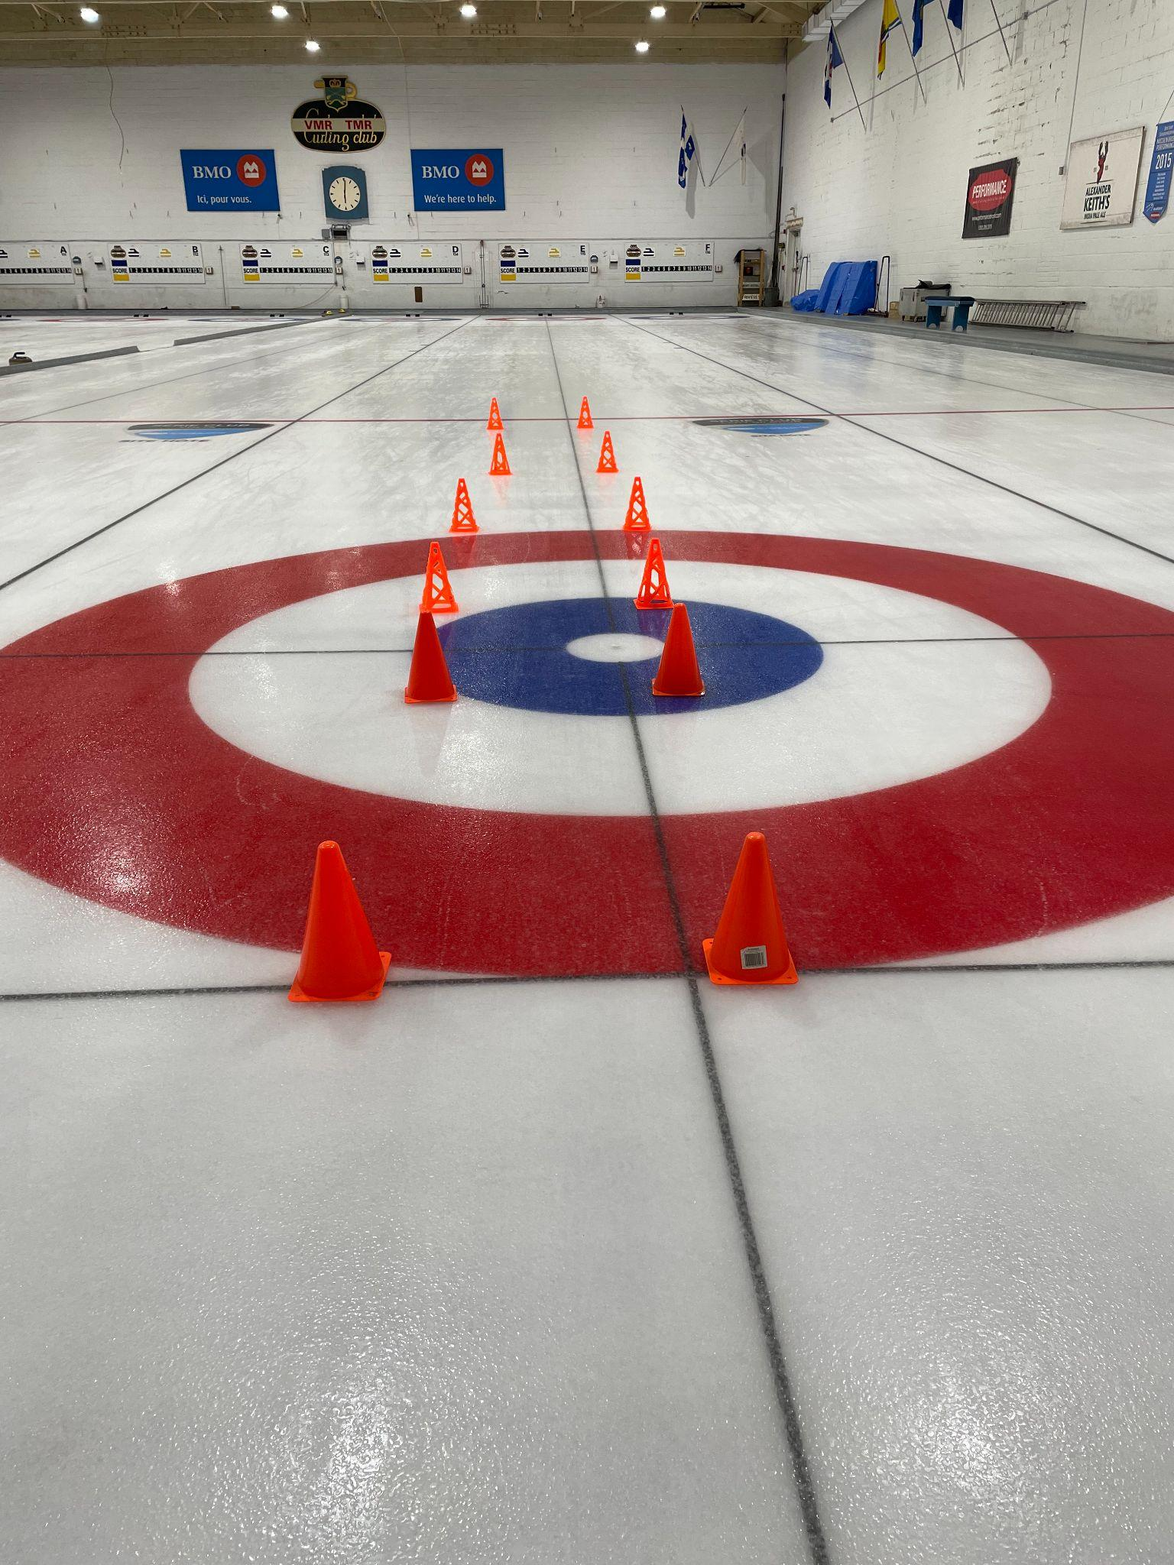
- Each participant must execute a shot with draw weight while mastering the technical elements of the starting position and the stages of the slide.
- The goal is to slide down the pathway without touching the plastic cups.
- The instructor may also add a plastic cup at the hog line on the slide path. When released, the rock should touch this cup. The instructor can make technical corrections.
10 minutes - Precision shots with two players per team (draw to the button)
- The instructor divides the participants in order to have two teams per sheet.
- Participants do a few practice slides and send a rock to the end and back.
- Two participants per team are chosen to perform the marksmanship shot (draw to the button). There is a skip and two sweepers for each shot.
- Each chosen participant throws one rock with the objective of getting as close to the button as possible.
- Note the score of each player (cover the central part of the button = 5 points, touching the button = 4 points, 4 foot = 3 points, 8 foot = 2 points and 12 foot = 1 point).
- The winning team will have the hammer in the first end of the game.

Game (45 minutes)
Game #1 - 3 ends
- Ask each team to establish a strategic plan for each end.
- Participants discuss their plan and the tactics that will be used.
- The instructor supervises the game and assists the participants by making minor corrections to the position in the hack and of the slide.
- Participants can use any type of shots for this game.
- After each end, the participants count the points and post them on the scoreboard.

*The instructor emphasizes the technical aspects of the slide and the communication between players.

Stretching session (5 minutes)
5 minutes - Stretching session
- The instructor asks participants to name some stretching exercises or yoga positions that can help the body recover and relax after curling.
- Choose three or four stretches and hold each position for 30 to 45 seconds.
- Participants lead the stretching session under the supervision of the instructor.

End of the session, thank the participants and announce the theme for the next session!

WEEK 8 - Objectives/Nutrition/Training

Goals
- Setting objectives
- Nutrition/hydration before, during and after a game
- Physical training and recovery

Off-ice session (60 minutes)
Review of the points seen in last week’s session
20 minutes - Setting goals
- The instructor asks each participant to mention a goal that they would like to set for the next season.
- The instructor discusses the importance of setting goals and what is important in order to achieve them (goals must be realistic and achievable).
20 minutes - Nutrition-hydration before, during and after the game
- The instructor presents some tips on diet and hydration that should be considered when playing the sport of curling.
10 minutes - Physical training and recovery
- The instructor discusses with the participants the basics of physical training and recovery related to the sport of curling.
10 minutes - Warm-up session - The ball game
- The group should sit down to form a large circle (maximum 12 participants per circle).
- The instructor has three balls in their hands (tennis ball or stress ball). Begin by throwing a ball to one of the participants. Then the participant has to throw the ball to another participant and so on until the ball returns to the instructor. (Always throw to the same person and receive from the same person.) After two or three rounds the instructor adds a second ball into play and finally a third ball. The goal is to do as many laps as possible without dropping a ball.

*This exercise will help participants improve their concentration and pay attention to the task at hand.

Technical session on-ice (30 minutes)
5 minutes - Sliding with and without a broom (or stabilizer)
- Each participant takes a few slides with their broom or their stabilizer towards a target that the instructor will have placed on the playing surface.
- Once participants have warmed up, the instructor sets up the targets near the hog line and each participant attempts to slide toward the target without a broom while maintaining their balance. Participants can assume the airplane position or the slide position as if they had a rock and a broom.
10 minutes - Drill #1: The pirate’s eye
- The instructor sets up a target at the nearest hog line and a target halfway between the hog lines.
- Each participant takes turns wearing the pirate's eye patch to hide their dominant eye*.
- The goal will be to work the line of delivery with the non-dominant eye.
- You can do this exercise without a rock or with a rock but without letting it go.
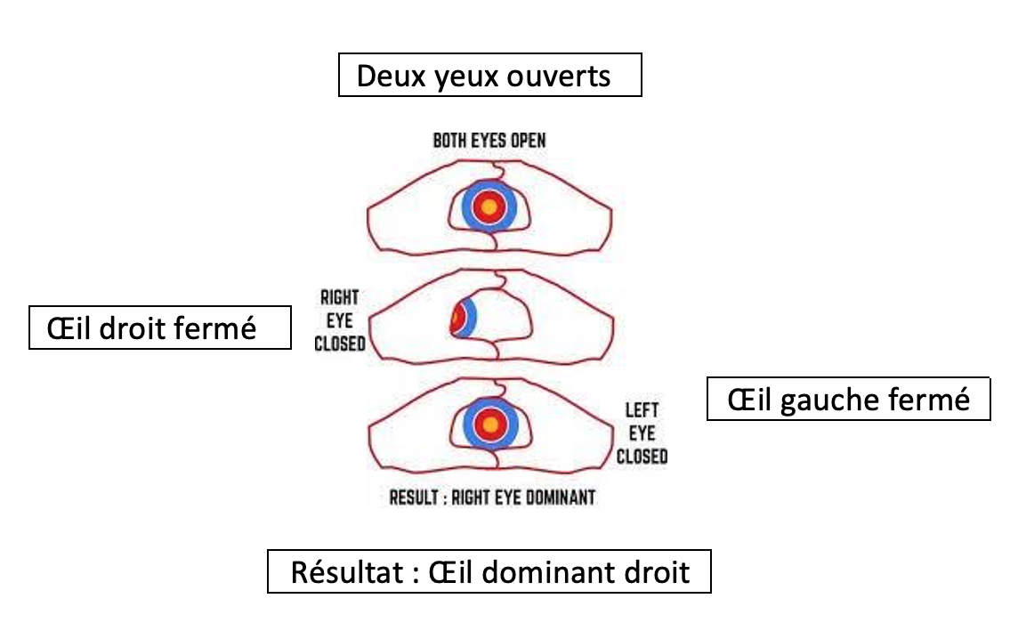
*To find the dominant eye, choose a distant object. Form a triangle with the thumbs and index fingers of both hands. With both eyes open, see the object in the center of the triangle. Close the left eye and look at the position of the object. Then close your right eye and see where the object is. The dominant eye will be the one with which the participant sees the object most in the center of the triangle.
15 minutes - Drill #2: The line of fire
- A skip, two sweepers and a shot maker. Rotate after every two shots.
- The goal of the drill is to get as many rocks as possible to finish their run touching the center line.
- The skip must therefore adjust the broom accordingly, the shooter must execute proper weight that falls within zones 1 to 11, and the sweepers must judge the speed in order to achieve the goal of finishing on the center line.

Game (30 minutes)
Game #1 - 2 ends
- The instructor divides the participants into two teams per sheet.
- Participants discuss a strategic plan for each end. The instructor can give a different scenario on each sheet (example: Sheet 1 - 7th end, the red team leads by 1 point and does not have the hammer).
- The instructor supervises the game and reinforces the participants' shot making routines so that they find better consistency in shooting. Each participant will have a different routine and the instructor can help them spot certain movements made in the stages of the shot (examples: a participant always touches their glasses or cleans his stone in a certain way).
- Participants can use any type of shot for this game.
- After each end, the participants count the points and post them on the scoreboard.

*The instructor emphasizes consistency of movement in the shooting routine of participants.

Stretching session (5 minutes)
5 minutes - Stretching session
- Choose three or four stretches and hold each position for 30 to 45 seconds.
- The instructor leads the stretching session.
- For the last exercise, ask participants to lie on their backs or sit in a comfortable position with their eyes closed (you can play relaxing music).
- The instructor asks participants to place both hands on their stomachs and breath-in for 5 seconds. Participants should feel their hands rise. Hold the position for 5 seconds. Exhale for 5 seconds, gently blowing air out your mouth. Finally, hold the position for another 5 seconds. Repeat 3-4 times.

End of the session, thank the participants and announce the theme for the next session!

Note for instructors: If you know elite athletes or health experts, it could be interesting to add them for the off-ice session (nutritionist, private trainer,…).

WEEK 9 - Review of techniques

Goals
- Review of the shot-making techniques
- Review of the sweeping technique
- Communication and strategic plan

Off-ice session (15 minutes)
Review of the points seen in last week’s session
10 minutes - Review of level 4
- The instructor asks questions to the participants about all the techniques learned during level 4 as well as on the following subjects: tournaments, mental preparation, nutrition, hydration and physical training.
5 minutes - Warm-up session
- With the help of the participants, the instructor reviews the benefits of stretching and the important muscle groups to warm up.
- Choose four or five exercises and perform each for about 30 to 45 seconds.
- The instructor leads the warm-up session with the participants.

Technical session on-ice (45 minutes)
Challenge - The trio
15 minutes – Challenge #1: The bowling game
- Each participant can take two or three practice slides.
- The instructor sets up plastic pins or targets anywhere in the playing area at the opposite end of the sheet.
- A skip, a shooter, two sweepers. Rotate after each shot.

Two choices for this exercise:
- The goal is to knock over one or more bowling pins with each thrown stone. The skip must therefore adjust their broom for the line of delivery and the shooter must throw the requested weight according to the called shot (1 point per successful shot).
- The goal is to have each rock finish within one broom length from a pin (1 point per successful shot).
15 minutes – Challenge #2: All in the house
- Divide participants into two teams of four per sheet.
- Each team chooses a rock colour and has a skip and two sweepers for each shot. Rotate every two shots.
- Each team's objective is to get as many rocks as possible in the house (1 point per successful shot).
15 minutes - Challenge #3: Crazy eight
- The instructor places eight stones of the same colour in the house.
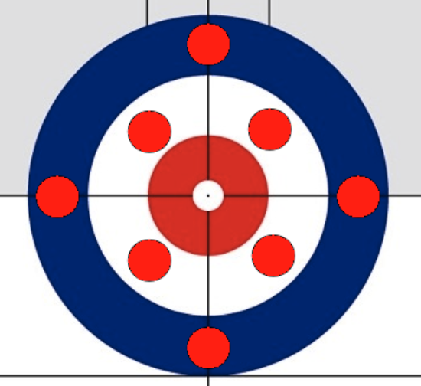
- A shooter, two sweepers and a skip. Participants rotate every two rocks.
- Participants must successfully remove the eight stones that are in the house and must try to keep the thrown stones in play.
- Request take-outs with any type of weight. Participants must adjust for the ice conditions.

*Goals for all three exercises are: precision, concentration, technique, communication.

Game (60 minutes)
Game #1 - 4 ends
- The instructor divides the participants into two teams per sheet.
- Each team is asked to come up with a strategy for each end.
- The instructor supervises the game and makes minor corrections on certain technical points or on communication between the participants.
- Participants can use any type of shot for this game.
- After each end, participants count the points and hang the score.
*The instructor emphasizes all the techniques learned in level 4.
**You can also play two games of two ends depending on the number of sheets available and the number of participants.

Stretching session (5 minutes)
5 minutes - Stretching session
- The instructor asks the participants to mention the benefits of stretching.
- Choose four or five stretches and hold each position for 30 to 45 seconds.
- Participants lead the stretching session under the supervision of the instructor.

End of the session, thank the participants and announce the theme for the next session!

WEEK 10 - Special day Level 4

Goals
- Games for the fun of it!
- Global review of all the points seen during level 4
- Program evaluation
*You can organize snacks or a meal for after the session
**Watch out for allergies!

Off-ice session (10 minutes)
Review of the points seen in last week’s session
5 minutes - The instructor takes a few minutes to recall the progress made during level 4
- This session allows a player to put into practice all the points seen during level 4.
- Remind participants to have fun.
- The instructor explains to the participants that they will have 10 minutes to practice before the game begins.
5 minutes - Warm-up session
- With the help of the participants, the instructor reviews the benefits of stretching and the important muscle groups to warm up.
- Choose four or five exercises and perform each one for about 30 to 45 seconds.
- The instructor leads the warm-up session with the participants.

Technical session on-ice (10 minutes)
10 minutes - Practice
- The participants take a few slides without rocks. They can also perform a few slides without a broom (or stabilizer). The instructor may also ask participants to slide towards a target at the hog line with their broom while closing their eyes after setting up in the hack.
- Each participant throws two rocks to the opposite end of the sheet and back.

Game (100 minutes)
10 minutes - Team precision shots
- The instructor divides the participants into two teams per sheet.
- The participants take a few practice slides without rocks.
- Each participant throws one rock to the opposite end and back.
- Each team then choses 2 players to complete the draw to the house, with a skip and 2 sweepers. Team A throws 2 out-turns, team B throws 2 in-turns.
- The team with the best result will have the last stone advantage in the first end of the game.
- For this special day, you can change the score for precision shots; Points: button completely hidden = 10 points, touching the button = 1 point, 4 foot = 6 points, 8 foot = 4 points, 12 foot = 8 points, outside the house = no point. (In this case, either the sweepers try to bring the rock all the way to cover the button or they try to make the rock stop in the 12 foot).

Game #1 - 3 ends
- The instructors can let the participants form their own teams or randomly draw teams.

Game #2 - 3 ends
- Instructors can change teams, positions or simply change opponents.

*You can also play three 2-end games.

Stretching session (5 minutes)
5 minutes - Stretching session
- With the help of the participants, the instructor reviews the benefits of the stretching exercises and muscle groups most used in curling.
- Choose four or five stretches and hold each position for 30 to 45 seconds.
- The instructor leads the stretching session according to the responses given by the participants.

End of the level 4 session!
- Thanks to the participants and make them fill out the evaluation forms for Level 4. Take a group photo.

