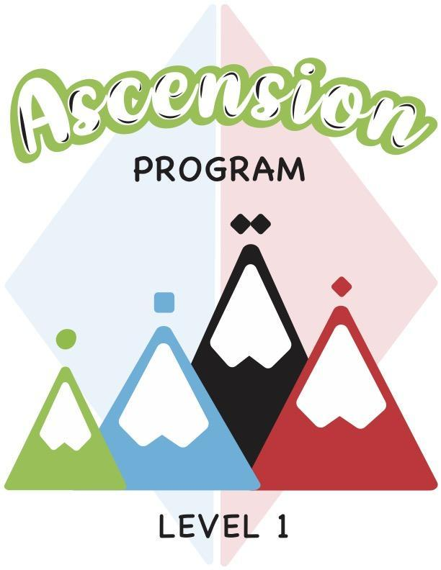

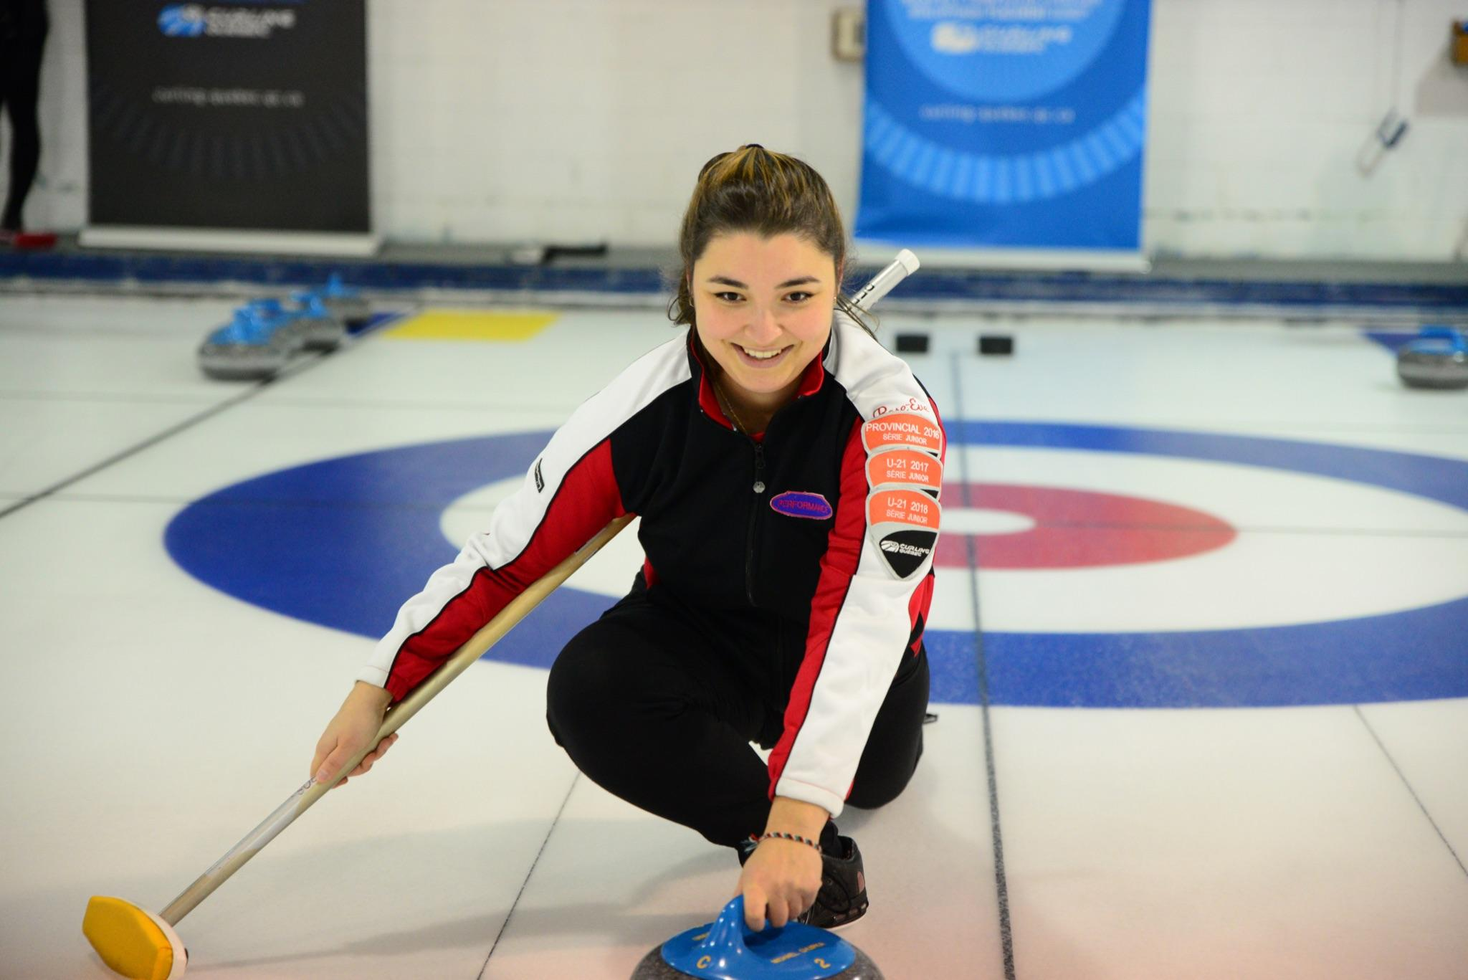

ABOUT ASCENSION

Ascension is a four-level program, with eight to ten weekly sessions per level. Each weekly training session is two hours long and is divided into three sections: off-ice learning session, on-ice learning session, and game play.

The program aims to teach the basic curling techniques and skills to adults. With this creative program, we want to offer a positive experience to all the participants in a safe and secure environment. We also offer a training session to the instructors who will be in charge of the program in each of their respective curling clubs.

The final goal is to have all participants reach an intermediate level of play which will help with member retention in each club offering the program.

In the novice level, participants will get to know the game as well as learn all of the curling terminology. Curlers will learn to sweep in the open position and will understand the reasons why it is important to sweep a stone. Players will also learn the starting position in the hack and how to complete a balanced slide with a stabilizer. The beginner level strategy aims to provide a general understanding of the basic game strategy with and without the hammer, and also teaches the participants the different types of shots and weights to select from.

Upon completion of the intermediate level, players will be able to sweep in both the open and closed positions and will understand the four key points to the sweeping position, know why to brush a stone and know how to communicate the speed of the stone to their team. Each curler will also be at ease with the starting position in the hack and will be able to execute a balanced slide using a broom, and will even be able to slide with their eyes closed. The intermediate-level strategy includes the basic strategy with and without the hammer, explains the different factors that influence the strategy choices, and teaches the differences between a defensive strategy, a cautious strategy and an offensive strategy. Players will also develop an understanding for adapting their game plan for the beginning, middle and end of the game.

After completing the advanced levels, each curler will be able to sweep with ease and will have a better understanding and better execution of the key points to the sweeping position, will master the footwork while sweeping and will be able to efficiently communicate the speed of the stone to their teammates. Participants will know how to correctly execute the recommended starting position in the hack, will be able to complete a balanced slide with or without a broom, and will be able to slide towards a target with their eyes closed, with or without a broom. The advanced-level strategy will master the different strategies based on the different game scenarios and will teach the participants how to adapt their strategies accordingly.

GENERAL RECOMMENDATIONS
- We strongly recommend holding a “club coach” clinic or a private training session for the instructors who will be teaching the classes. The private training session should be taught by someone who has their Competition-Introduction certification or higher. The goal for this workshop is to ensure that the instructors have a good understanding of the skills which will be taught throughout the course, and a general understanding of the program itself.

- This developmental league is geared towards a recreational level curler. The participants within each group will likely have many different skill levels and different physical abilities. We recommend that the instructors adapt the training sessions accordingly in order to maintain a safe environment at all times.

- In the event that an accident occurs during one of the sessions, the instructor must complete an accident report and send one copy to the club administrator(s) and one copy to Curling Quebec.

- We recommend that all instructors have their CPR/AED certification as an extra safety measure to be able to adequately respond to any accidents that may occur during the classes.

- Each class is divided into 4 sections (off-ice theory, on-ice training, game time as well as stretching). Each activity has a recommended time associated with it, but feel free to adapt the allotted time according to the number of participants, the ice availability or the skill level of the participants.

- If there are more than one group per level (more than 8 participants), we recommend dividing the players up by skill level so that the participants can all learn at a similar pace.

- For the beginner levels (1 and 2), we recommend rotating the players’ positions during the games so that they can get a feel for the different roles of each position. In the more advanced levels (3 and 4), we recommend that the instructors designate positions for each player based on their level of play.

- For the on-ice drills, especially for levels 1 and 2, the instructor or the participants should push the stones towards the side of the sheet after they have come to rest in order to prevent any accidents/collisions with the following stones. Only certain drills will require the stones to be left in play.

- It is recommended for the instructors to participate in the warm up, the stretching and the on-ice activities as a way of setting a good example for the participants.

- During the end-of-class stretching session, the instructors can also review everything that the participants have learnt up until that point.

- For more than one group per level, the club may decide to offer the program on multiple days of the week.

- It is recommended to increase the price of the course as the levels increase to account for the increased difficulty and to pay the instructors for their time.

Last but not least, don’t forget to have fun with the participants!

Table of contents
ABOUT ASCENSION 2
GENERAL RECOMMENDATIONS 4
Summary 9
WEEK 1 - Welcome/Introductions/Security 13
Goals 13
Off-ice session 13
Technical session on-ice 13
Game 17
Stretching session 17
WEEK 2 - Playing surface components/Slide position 18
Goals 18
Off-ice session 18
Technical session on-ice 19
Game 22
Stretching session 23
WEEK 3 - Ethics/Orientation of the game/Position in the hack 24
Goals 24
Off-ice session 24
Technical session on-ice 25
Game 26
Stretching session 26
WEEK 4 - Holding the rock/Rock rotation/Release 27
Goals 27
Off-ice session 27
Technical session on-ice 27
Game 30
Stretching session 30
WEEK 5 - Sweeping / Review of the slide 31
Goals 31
Off-ice session 31
Technical session on-ice 32
Game 33
Stretching session 34
WEEK 6 - Line of delivery 35
Goals 35
Off-ice session 35
Technical session on-ice 36
Game 37
Stretching session 38
WEEK 7 - Weight control/Weight judgement 39
Goals 39
Off-ice session 39
Technical session on-ice 39
Game 41
Stretching session 41
WEEK 8 - Basic notions about strategy 42
Goals 42
Off-ice session 42
Technical session on-ice 42
Game 43
Stretching session 44
WEEK 9 - Introduction of the role of each player 45
Goals 45
Off-ice session 45
Technical session on-ice 45
Game 46
Stretching session 46
WEEK 10 - Special Day Level 1 47
Goals 47
Off-ice session 47
Technical session on-ice 47
Game 48
Stretching session 48

SUMMARY - LEVEL 1

Week 1

Theme: Welcome/Introductions/Safety
Key Points:
- Welcome/Introductions
- Description of the program
- Curling safety/First contact with the playing surface

60 | 60 | X

Week 2

Theme: Game components/Sliding position
Key points:
- Description of the playing surface
- Basic slide position
- Sliding with a stabilizer

45 | 75 | X

Week 3

Theme: Ethics/Game basics/Position in the hack
Key Points:
- General curling ethics
- Scoring/Measurements/Equipment
- Position in the hack

60 | 60 | X

Week 4

Theme: Holding the rock, rotation and release
Key Points:
- Skip’s signals
- Holding the rock
- Releasing the rock

45 | 75 | X

Week 5

Theme: Sweeping and sliding review
Objectives:
- Introduction to sweeping in the open position
- Footwork on the ice
- Understanding the impact of sweeping
- Review steps of throwing and release

45 | 45 | 30

Week 6

Theme: Line of delivery
Objectives:
- Review of position in the hack
- Steps for a successful slide towards the target
- Sliding with a stabilizer towards the target

30 | 60 | 30

Week 7

Theme: Weight control and weight communication
Key Points:
- 3 different types of throws
- Hog line to backline zone breakdown
- Developing a sense for the speed of the rocks

30 | 60 | 30

Week 8

Theme: Basic strategy
Key Points:
- Basic strategy with or without the hammer
- Factors that can influence our choices
- Which part of the play area to control

30 | 60 | 30

Week 9

Theme: Roles and responsibilities of each player
Key Points:
- Different responsibilities for each other
- Communication between the players
- What should be said and not said

30 | 60 | 30

Week 10

Theme: Special day - Level 1
Key Points:
- Fun activities and a game
- Global review of points seen during Level 1
- Course evaluation by the participants

15 | 45 | 60

Recommended time per session for the following sections
Off-ice technique | On-ice technique | Game play

Level 1 equipment needed:

On-ice

- Grippers
- Sliders
- Stabilizers
- Brushes
- Orange soccer cones
- Empty tissue boxes
- Plastic cups or buckets
- Spoons
- Foam balls or ping pong balls

Off-ice

- Participant’s guide or notebook
- Pens or pencils
- Plastic stone or gym curling rock
- Magnetic board
- Magnets
- Dry erase markers for the magnetic boar

WEEK 1 - Welcome/Introductions/Security

Goals
- Welcome/Participant introductions
- Description of the program
- Curling safety/First contact with the playing surface

Off-ice session (60 minutes)
10 minutes - Welcome
- Welcome the participants
- Introduction of the instructor(s)
- Presentation of the participants
10 minutes - Program description
- Presentation of the development league as a whole (goals, program duration, duration of sessions and themes for Level 1).
- Presentation of the Curling Canada video - https://www.youtube.com/watch?v=WXHh_wadqPw
30 minutes – Safety related to the sport of curling
- The different risk factors
- Equipment used
10 minutes - Warm-up session
- Why is it important to warm up before doing a sport?
- Choose four to five exercises and perform each one for about 30 to 45 seconds.
- The instructor directs the warm-up session.

Technical session on-ice (60 minutes)
15 minutes – First contact with the play area
- Presentation of the ice and surrounding environment
- Ensure that participants have two non-slip soles for the first contact with the ice.
- Participants take a broom and move slowly on the playing surface (to get comfortable while moving on the ice. The participants can lean on their brooms when moving for more stability).
15 minutes – Drill #1: The slide position
- The instructor explains the slide position and gives a demonstration (the participants watch from the side of the sheet).
- Each participant squats and places their hands on the sideboard of the sheet while stretching one leg out behind them to achieve the sliding position (first with and then without a gripper).
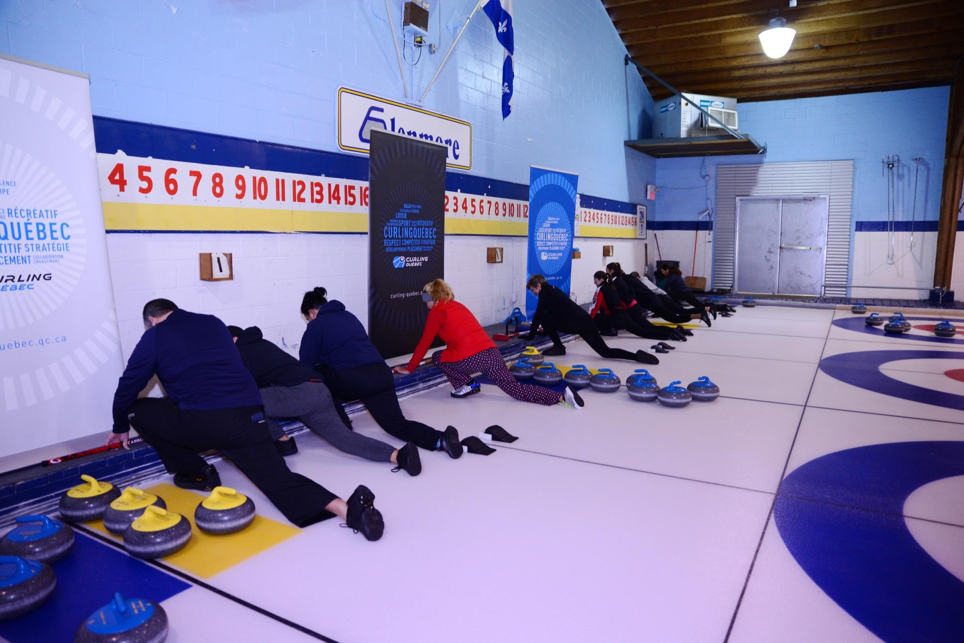
- Participants then pick up their broom and turn to face the ice, having the sideboard behind them. Each participant places their broom in front of them on the ice and holds the broom with both hands, about shoulder-width apart. In the squatting position, they push from the sideboard, to reproduce the thrust from the hack and end up in the sliding position.
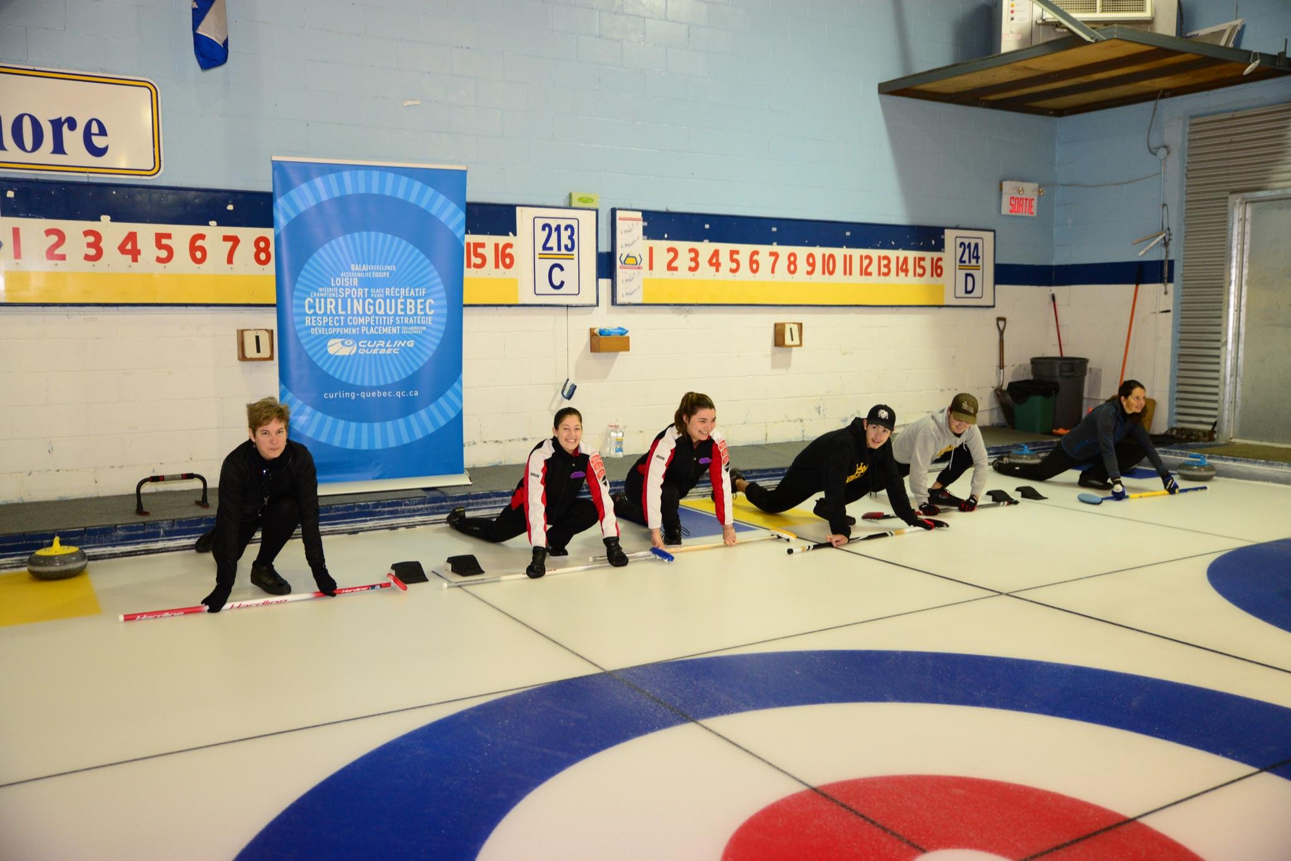
- Start again with the opposite leg to see which position is the most comfortable for each participant (the participant will then know whether they are a left-handed or a right-handed slider).
- Do this a few times so that each participant can find their balance.
15 minutes – Drill #2: The curling rock
- Divide participants into teams of two. The participants stand face-to-face on each sideline of the sheet.
- One of the participants from each team will have a rock in front of them.
- The instructor explains what a curling rock is and recalls the safety recommendations (show the crown under the stone, explain the effect of the pebble, etc.).
- The instructor then demonstrates that there are two possible rotations during the slide and demonstrates. Start the handle at 2 o’clock or 10 o’clock and finish the movement at 12 o’clock.
- The participants throw the rock, back and forth, with each rotation, trying to achieve a complete rotation for each throw.
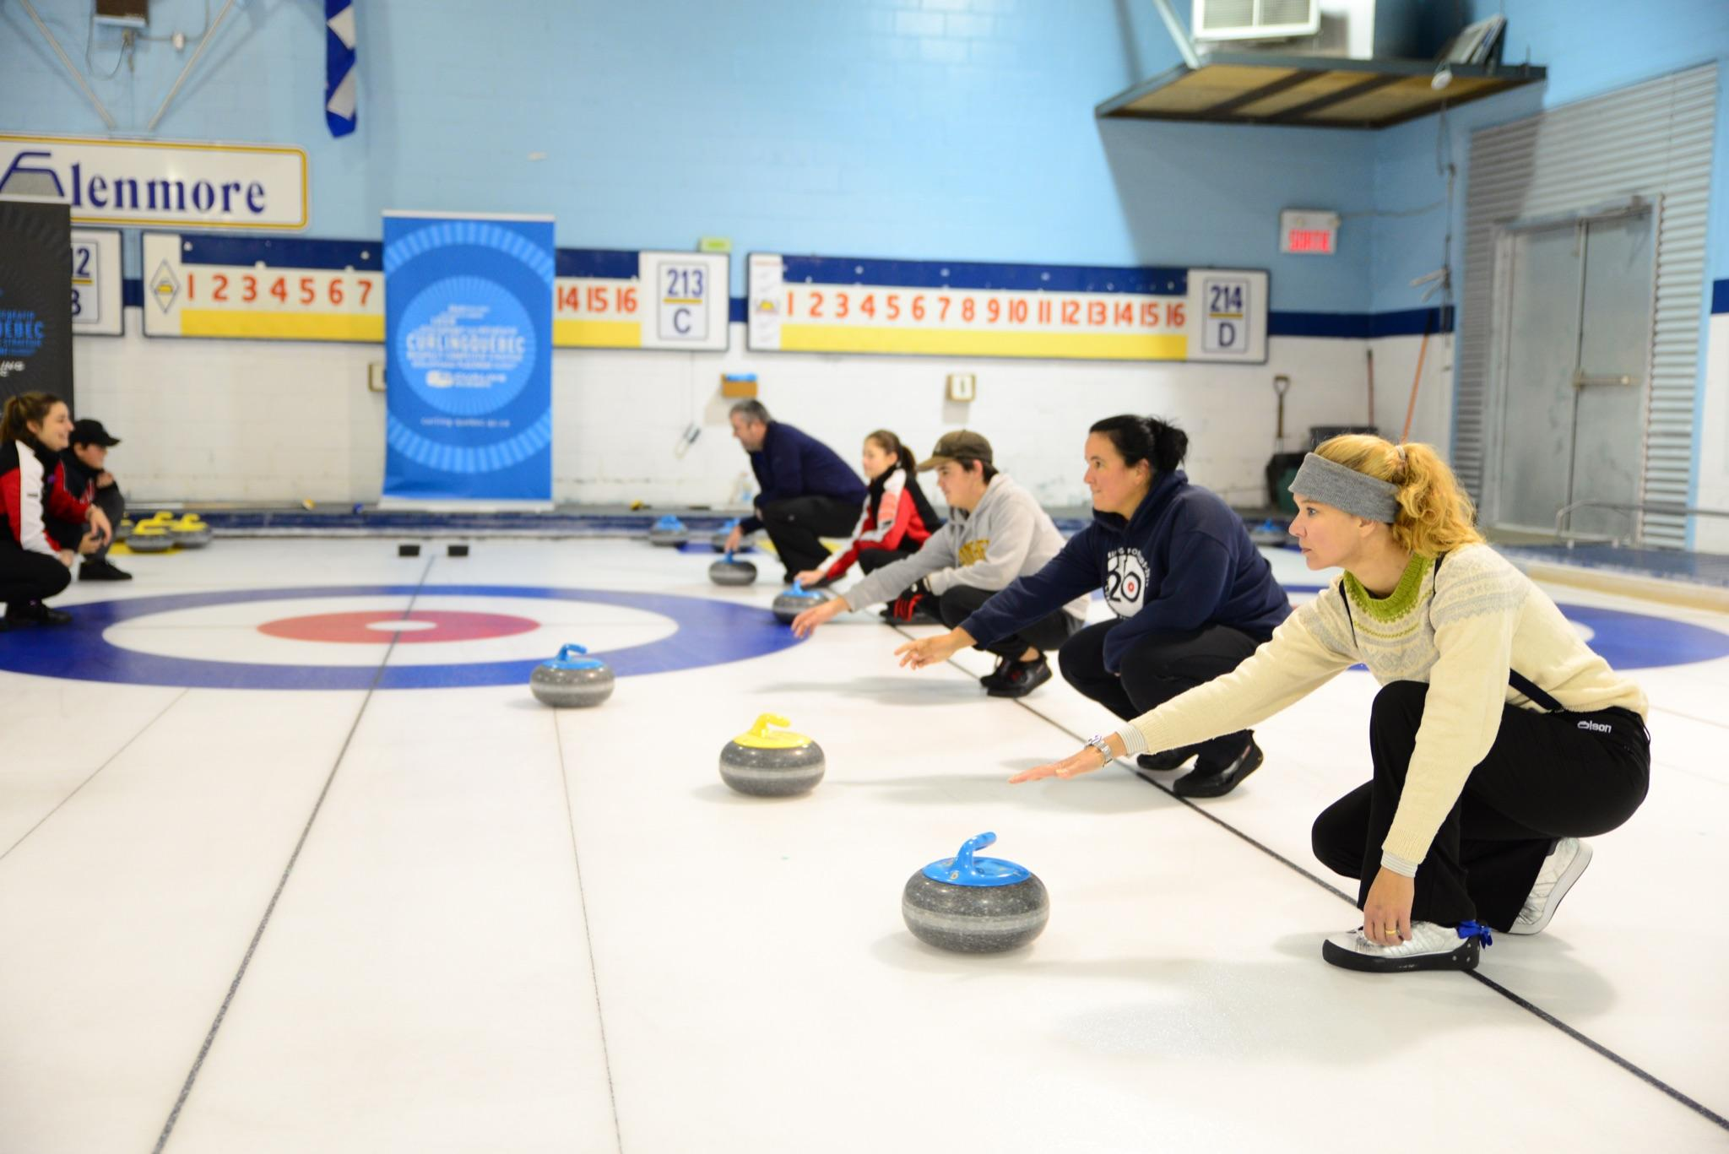
15 minutes – Drill #3: My first slide
- The instructor gathers the participants in front of the hack.
- The instructor explains what the hack is and which side will be used by left- and right-handers.
- The instructor reviews the safety tips for using the slider and explains how to get set up in the hack.
- Participants take turns squatting in the hack with their broom in front of them on the ice (as done in drill #1).
- Without using a weight transfer, explain how to move the sliding foot forward until it is under the belly button and how to push forward with the hack leg.
- Repeat a few times to develop a feeling of ease in the sliding position.
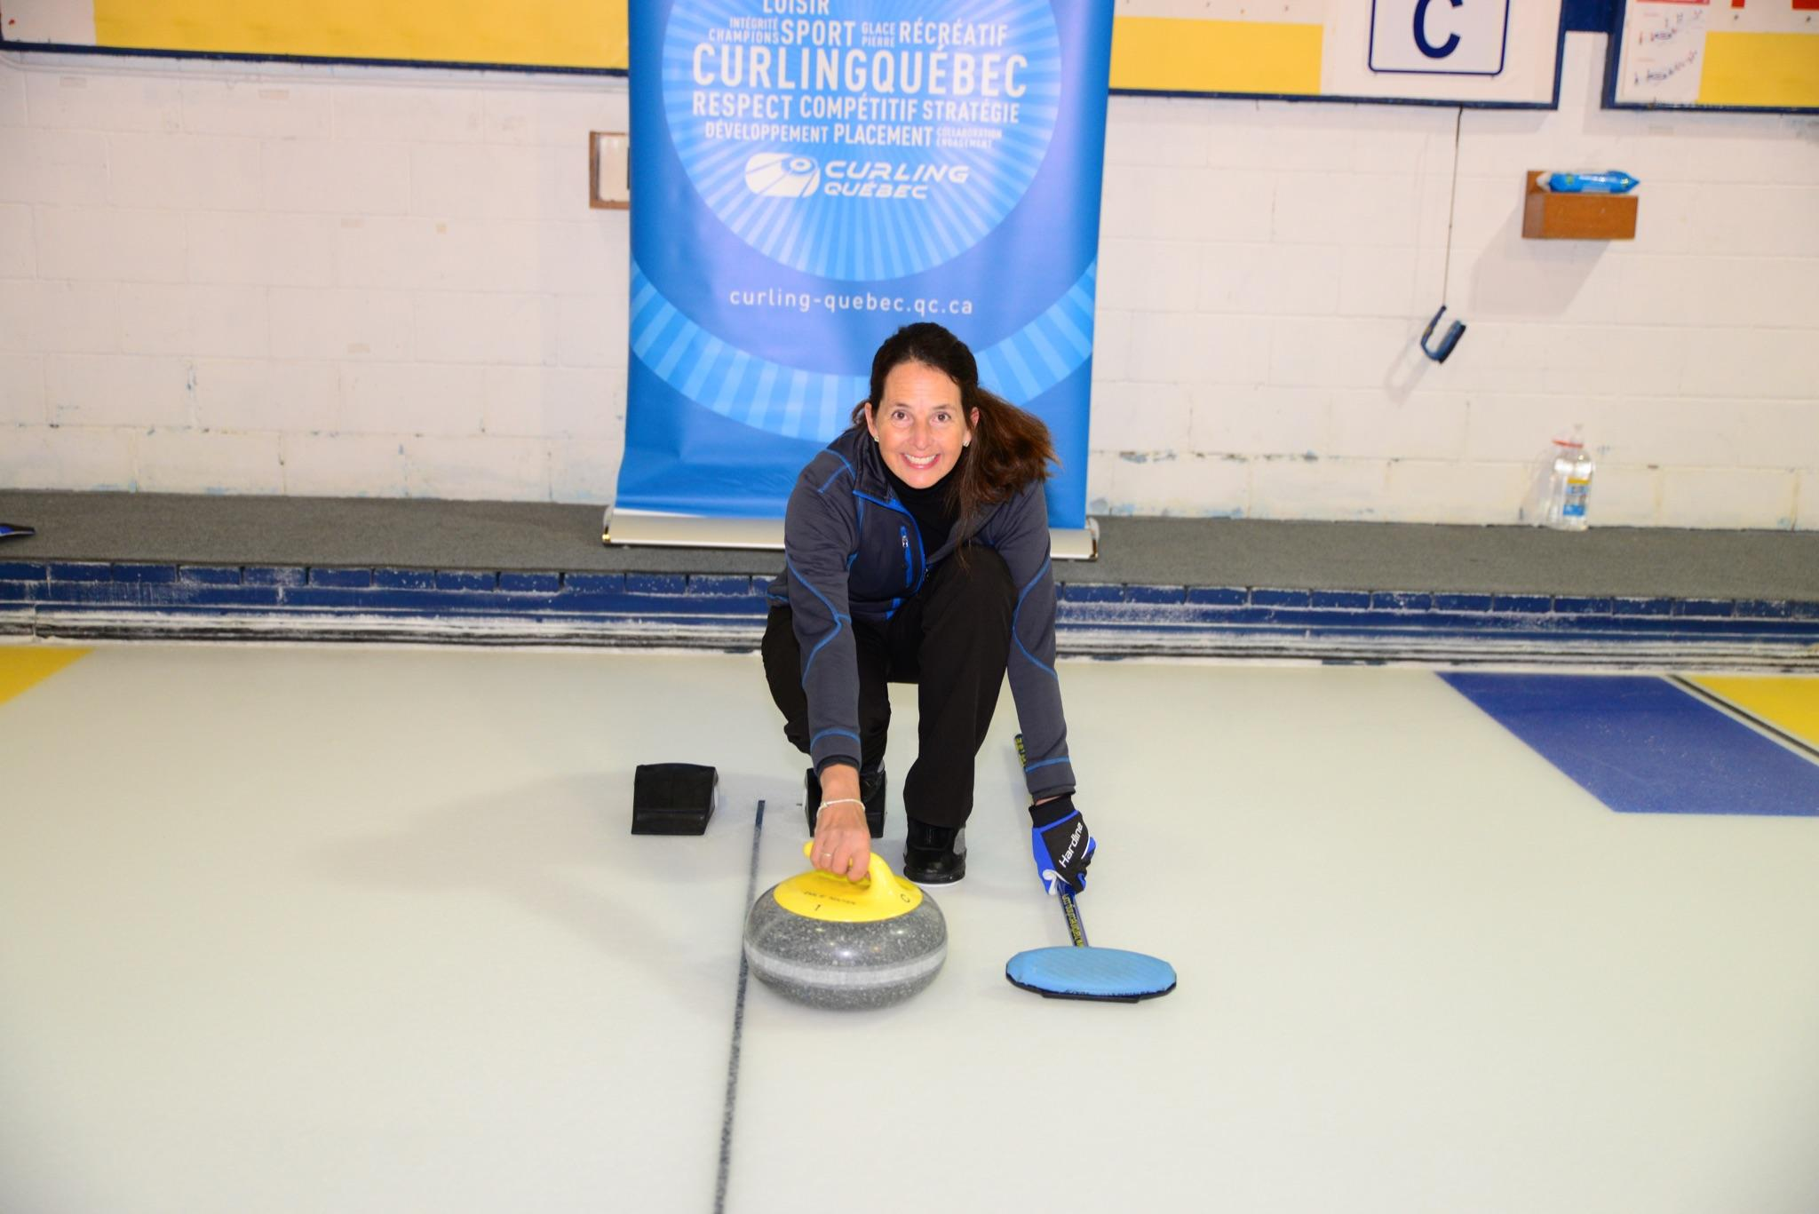

Game (0 minute)
- No game for this session

Stretching session (5 minutes)
5 minutes – Stretching session
- Why is it important to stretch after any sport?
- Choose four to five stretches and hold the position for 30 to 45 seconds each.
- The instructor directs the stretching session.

End of the session, thank the participants and announce the subjects that will be covered in the next session!

WEEK 2 - Playing surface components/Slide position

Goals
- Playing surface description
- Basic sliding position
- Sliding with a stabilizer

Off-ice session (45 minutes)
5 minutes - Welcome the participants, re-introduce the participants and review of the points from the previous week
25 minutes - Curling terminology
10 minutes – Review the key points of the basic sliding position / Using the off-ice position
Here are some questions we can ask participants in order to improve their learning.
- Are the participants right or left handed sliders?
- Which foot will have the slider?
- Where should the sliding foot be when sliding?
- What position should my shoulders and hips be in?
- Where should I be looking?
- In what direction should my slider foot, my rear foot point?...
5 minutes - Warm-up session
- Reminder of two benefits of warming up (e.g. preparing the body for activity and activating blood circulation).
- Choose four to five exercises and perform each one for about 30 to 45 seconds.
- The instructor directs the warm-up session.

Technical session on-ice (75 minutes)
20 minutes – Drill #1: Review the sliding position with the broom on the ice in front of the participant.
- The instructor reminds which side of the hack should be used and has only one or two loose sliders on each sheet to optimize everyone's safety.
- The participants take turns positioning themselves in the hack and putting both hands on the broom in front of them.
- They bring the sliding foot under the belly button and push into the sliding position.
- Slide to the close house button (T-line)
- Slide through the house
- Slide to hog line
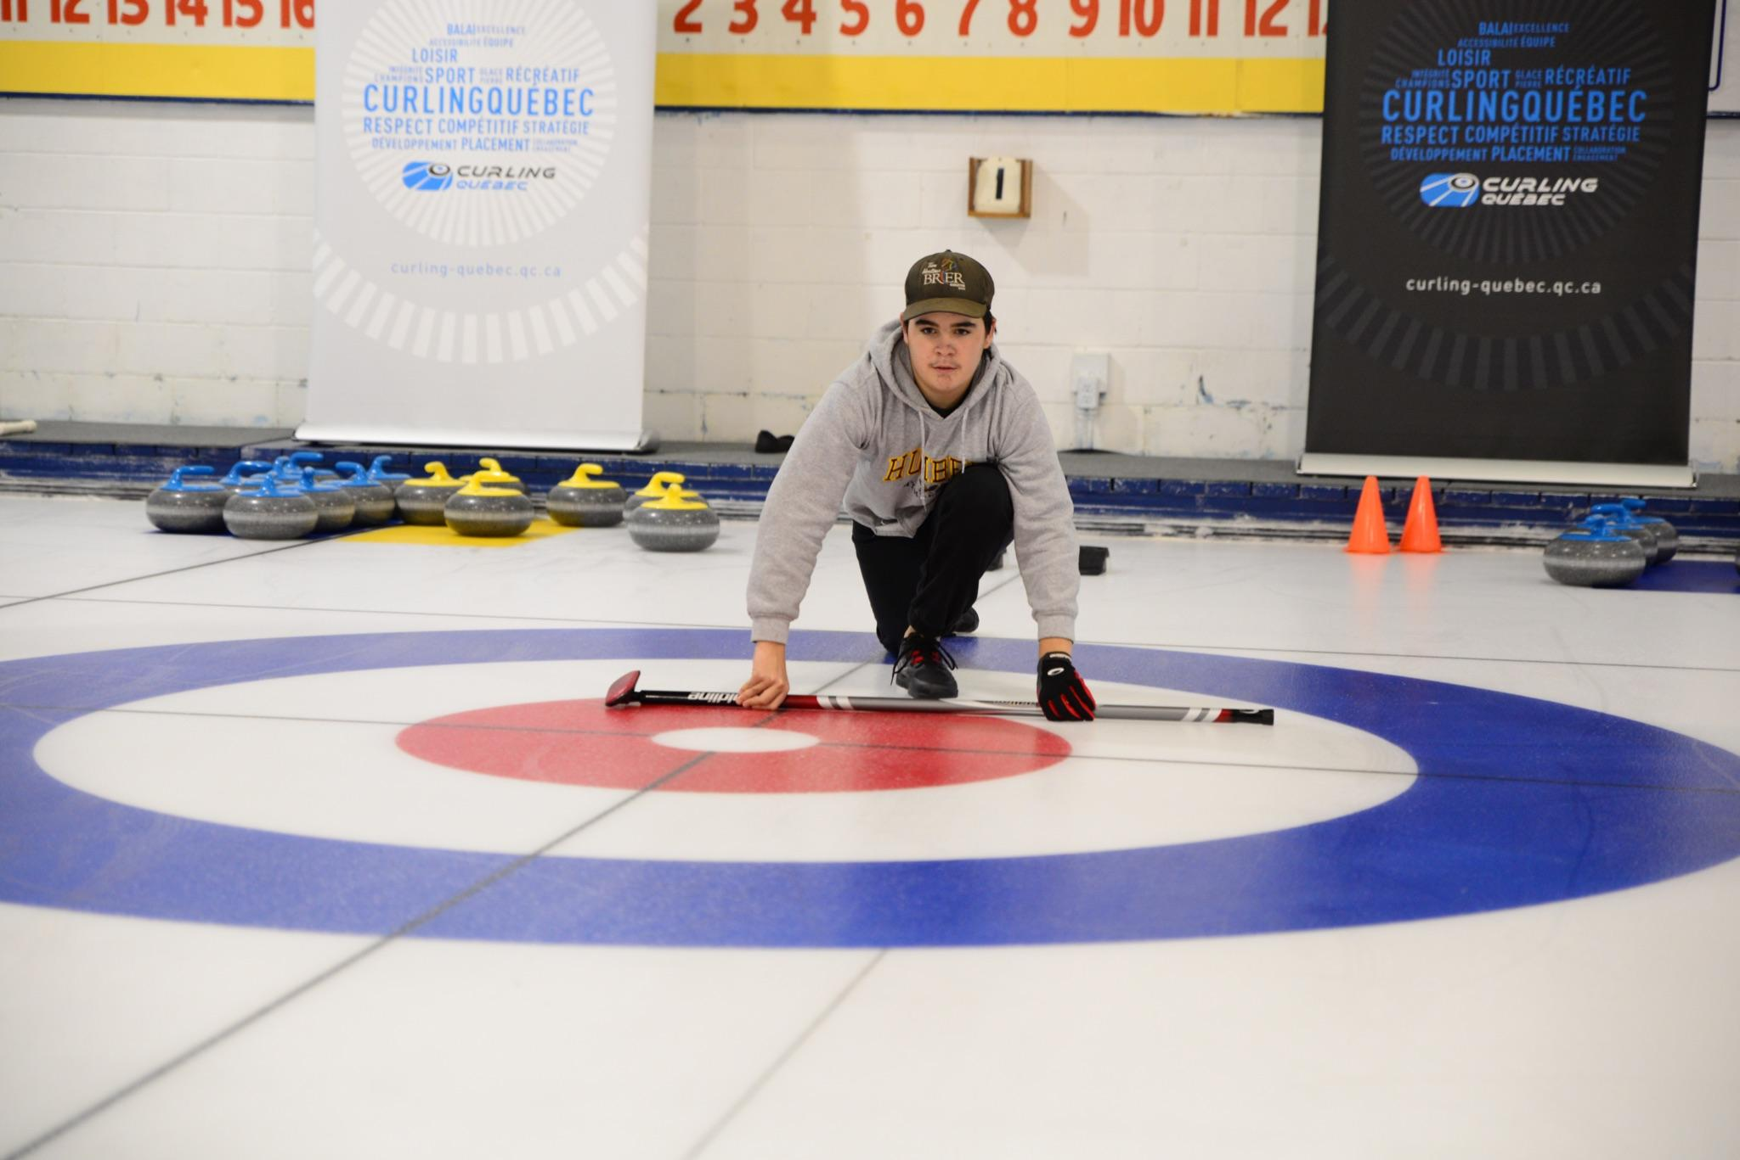
20 minutes – Drill #2: Sliding with a stabilizer and a stone (without letting go of the stone)
- The instructor explains and demonstrates the transition of the slide using a stabilizer in one hand and a stone in the throwing hand.
- Participants repeat the steps from drill #1 without letting go of the stone.
- The instructor asks the participants to keep their chin up and their eyes forward throughout the slide (you can install a cone at the hog line to use as a target).
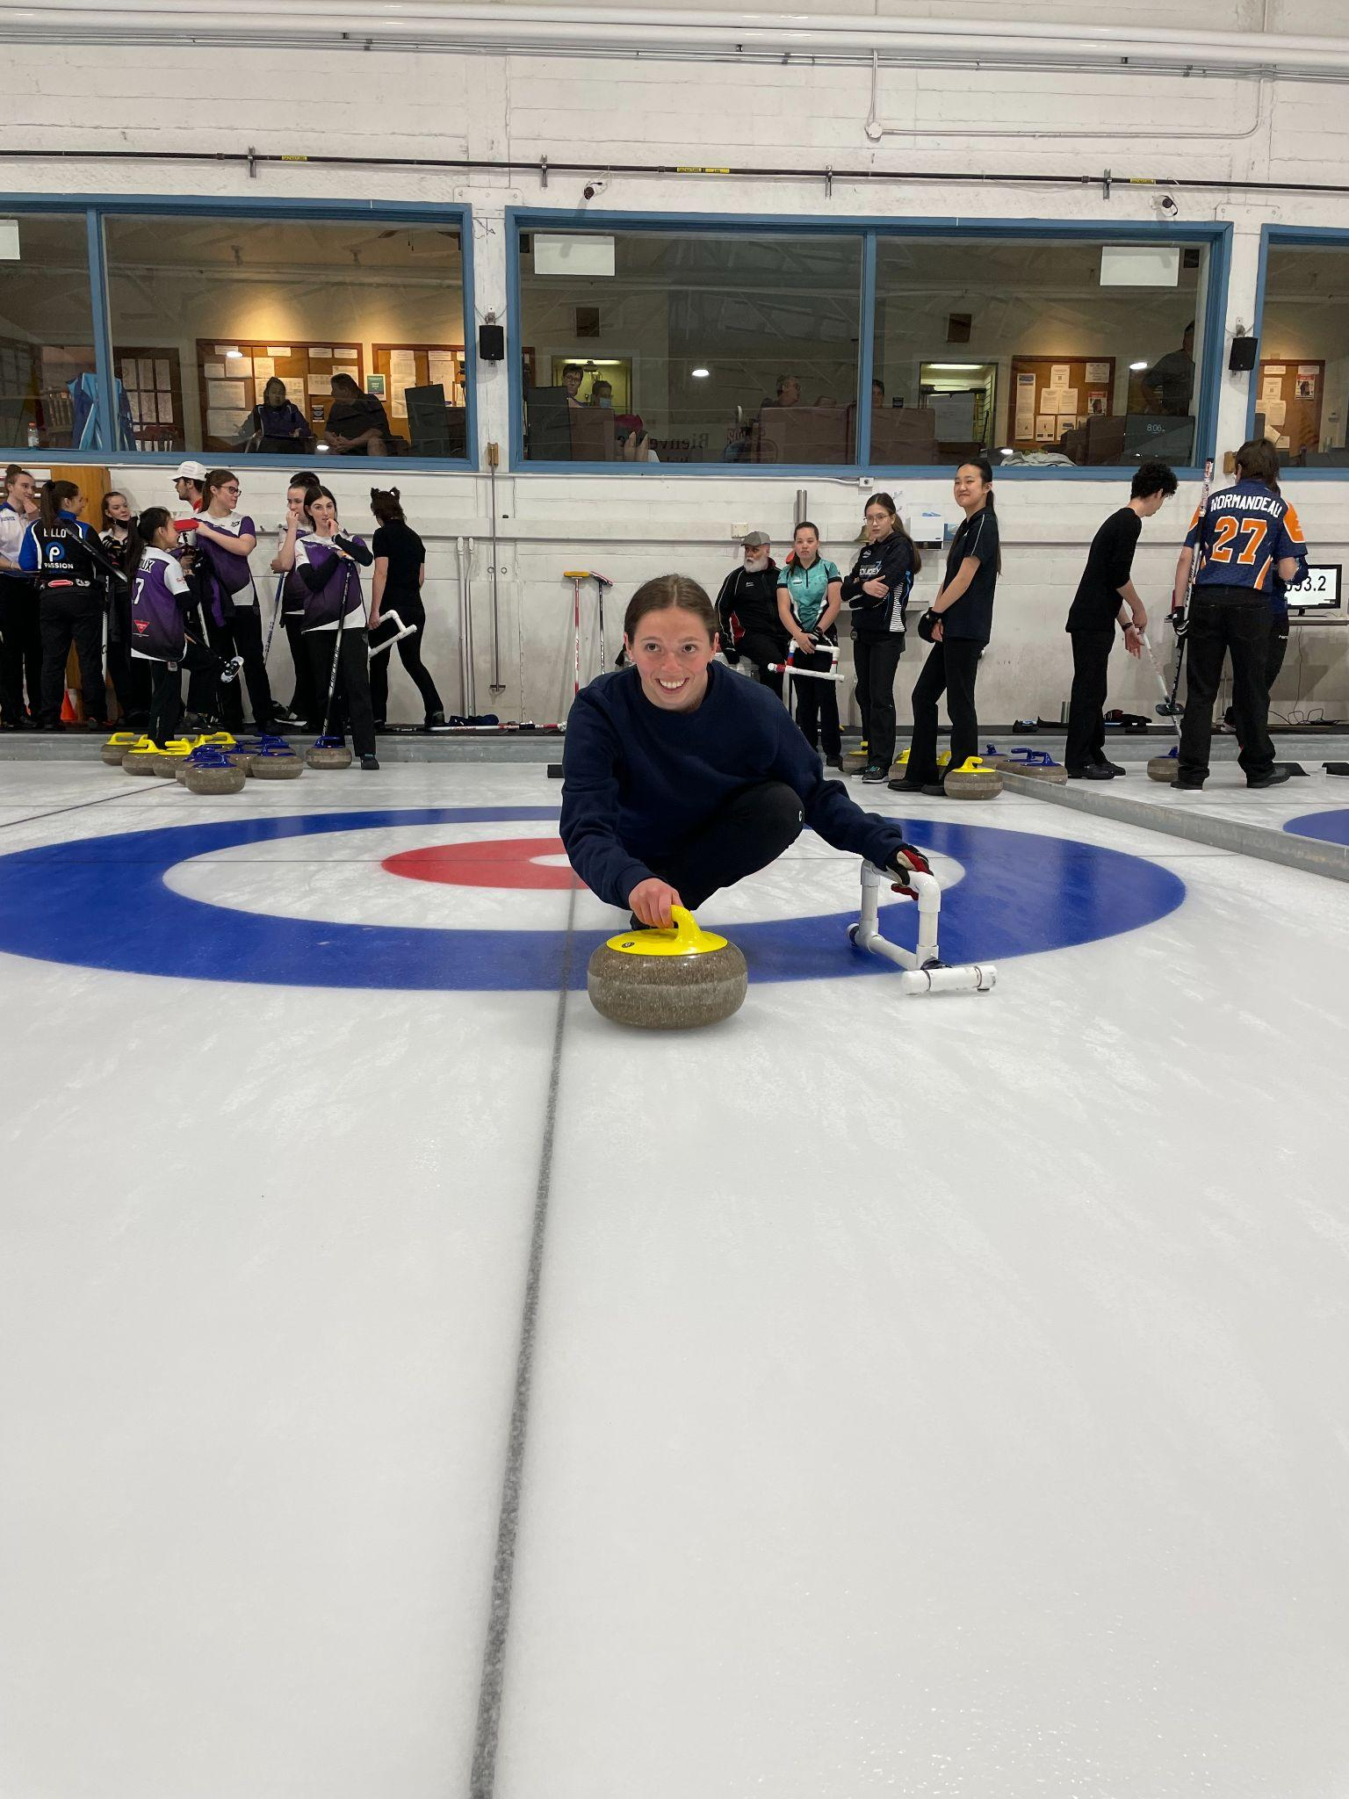
- Repeat a few times for each participant.
20 minutes – Drill #3: Sliding with a stabilizer without a stone
- Once the participants are more comfortable with the stabilizer, we want to practice their balance.
- The instructor asks the participants to settle comfortably in the hack (without correcting technical points on their position) and to hold the throwing arm as if they wanted to shake someone's hand.
- The instructor first stands in the 12-foot circle closest to the hog line and the participant must gently push out of the hack in order to go and shake their hand while remaining balanced in the sliding position. The instructor gradually moves further back towards the hog line.
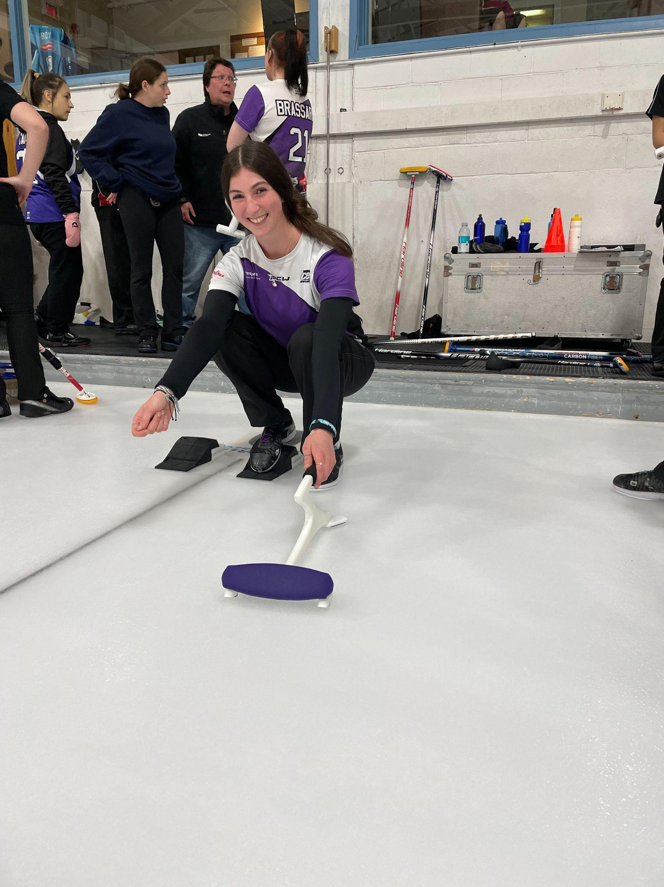
- Repeat a few times for each participant.

15 minutes – Drill #4: My first throw
- Once the participants are more comfortable with the basic slide, the instructor asks everyone to settle into the hack with a stabilizer and a stone. This will be players’ first time throwing a stone (do not correct the technical elements of the slide).
- The instructor places one or two colored cones in the distant house to give targets to the participants. The instructor then asks the participants to try to aim at one of the cones, keeping their eyes on this target throughout the slide.
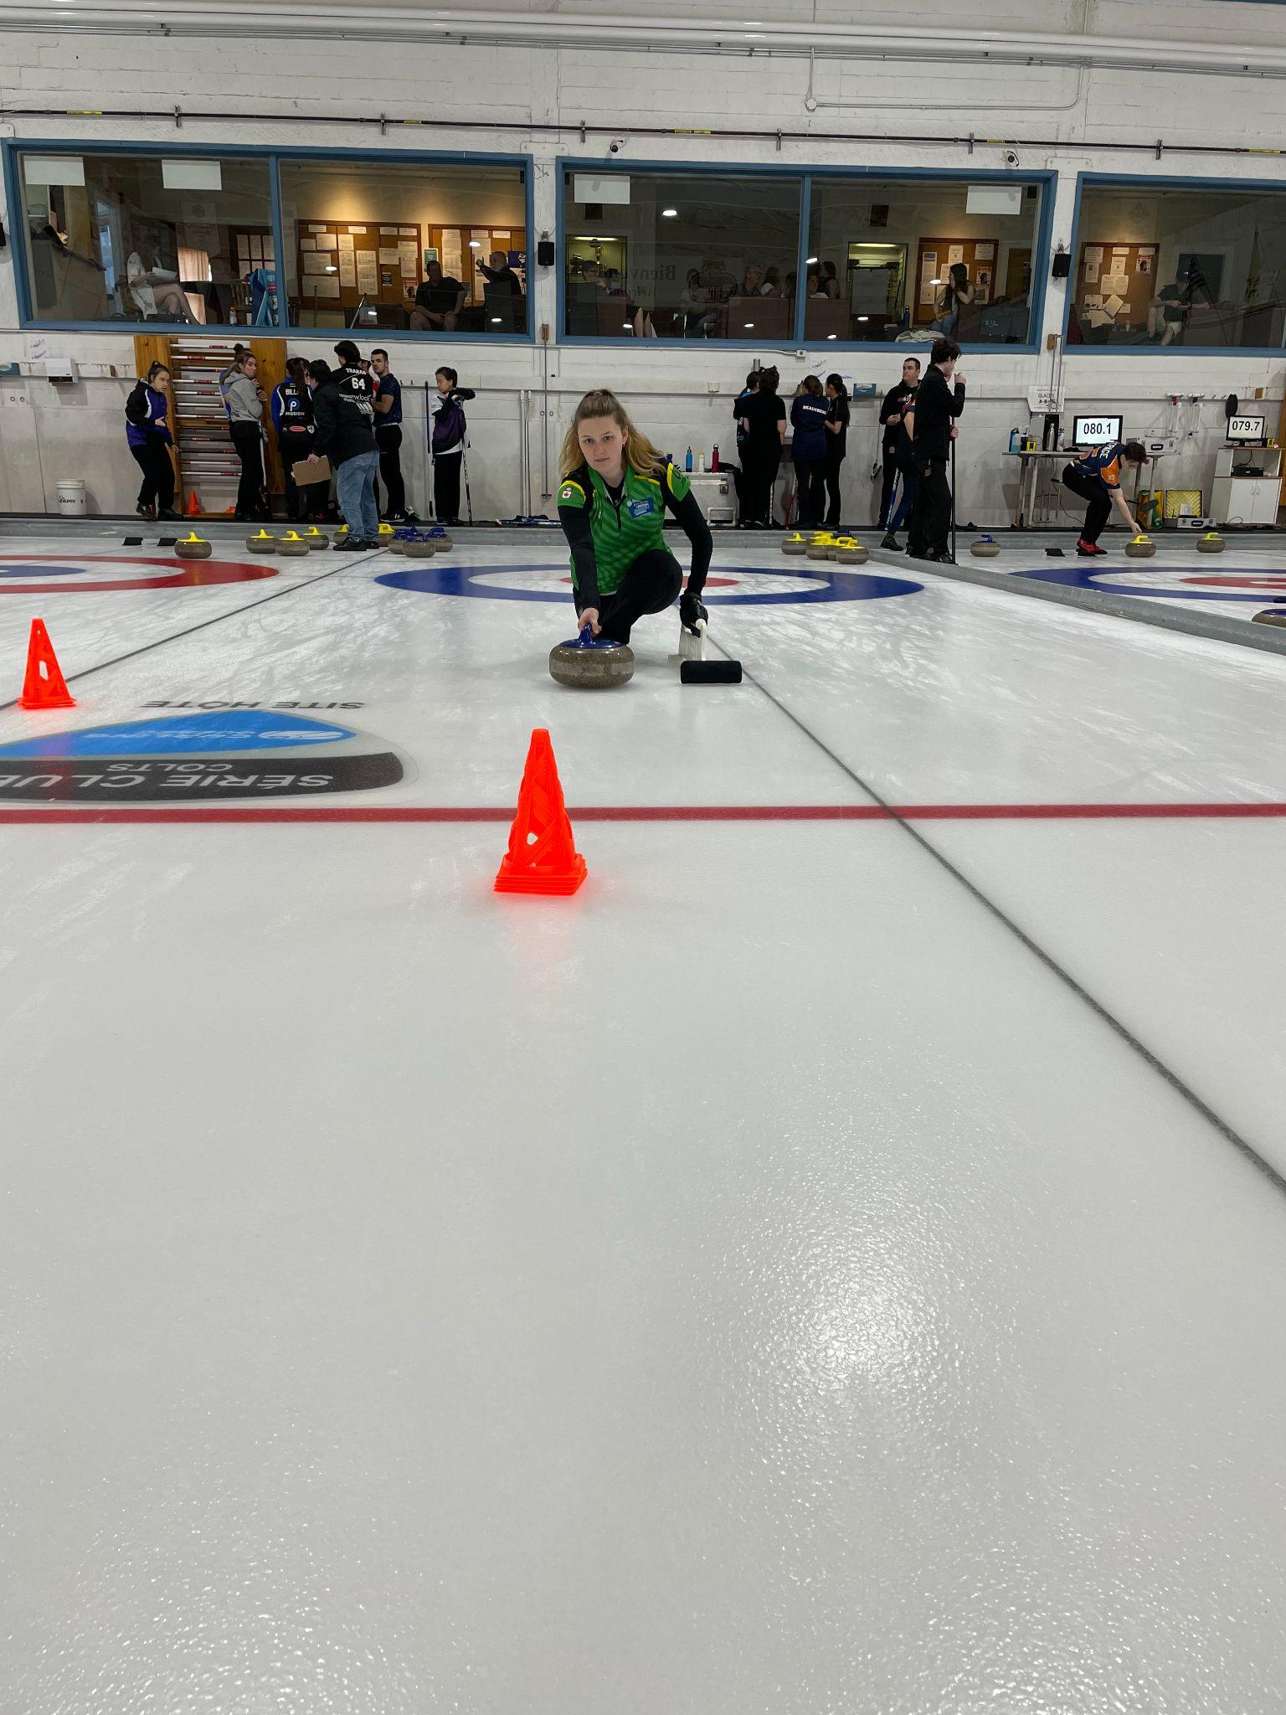
- The instructor demonstrates a slide (ensuring not to move too quickly in the hack) and throws either a guard or a draw. Ask the participants not to throw too hard, the goal is to keep their balance.
- Participants throw two or three throws each.

*The purpose of these drills is to allow participants to be more comfortable on the ice and improve their balance.
**For all of these drills, avoid going into the details of weight transfer. Ask participants to lift their hips slightly, bring the sliding foot under the belly button and push forward.

Game (0 minute)
- No game for this session

Stretching session (5 minutes)
5 minutes – Stretching session
- Reminder of the two stretching goals (e.g. reducing the risk of injury and relaxing the muscles).
- Choose four to five stretches and hold each position for 30 to 45 seconds.
- The instructor directs the stretching session.

End of the session, thank the participants and announce the subjects that will be covered in the next session!

WEEK 3 - Ethics/Orientation of the game/Position in the hack

Goals
- General ethics in curling
- Orientation of the game: stones/ice/button/pebble/equipment/ scoring/measures
- Position in the hack

Off-ice session (60 minutes)
Reminder of the points seen in the previous week
10 minutes - Ethics in the sport of curling
- The instructor mentions some basic values and rules to be observed in the practice of the sport of curling.
30 minutes – The orientation of the game
- The instructor describes the different elements that make up the orientation of the game:
- Stones/Ice/Pebble
- Equipment
- Scoring
- Measurements (to be demonstrated on ice)
15 minutes - Position in the hack
- The instructor explains the key points to the correct starting position with the stabilizer.
5 minutes - Warm-up session
- The instructor asks a few participants which muscle groups are important to warm up before curling.
- Choose four to five exercises and perform each one for about 30 to 45 seconds.
- The instructor directs the warm-up session with input from the participants.

Technical session on-ice (60 minutes)
10 minutes – Orientation of the game
- The instructor takes the participants to the scoreboard and explains a scenario to teach the participants how to place the numbers in the right place on the board.
- The instructor positions two stones equidistant from the button and demonstrates how to measure the stones.
- The instructor can also demonstrate how to measure a stone in the free guard zone (whether it touches the 12-foot circle or not).
10 minutes – Position in the hack - reminder of the important points / position a cone or target at the hog line
- The instructor demonstrates the important points to remember for a proper position in the hack.
- The participants take turns getting into position in the hack and the instructor makes the necessary corrections.
- Participants will align their bodies to the target at the hog line (move the target left and right to demonstrate the changes that need to be made in the hack).
20 minutes – Drill #1: Slide towards the target
- Participants perform the drill without a stone and then with a stone.
- Participants must pay attention to proper positioning in the hack so that they can slide to the target at the hog line.
- Repeat a few times, changing the position of the target.
20 minutes – Drill #2: Slide with a different pushing force towards a target
- The instructor installs three to four cones on the playing surface (remaining in the first half of the sheet) and asks the participants to set themselves up in the hack so that they can slide towards the targets.
- Participants must adjust the strength of their push from the hack to get to the targets that are positioned at different distances but must not slide past them.
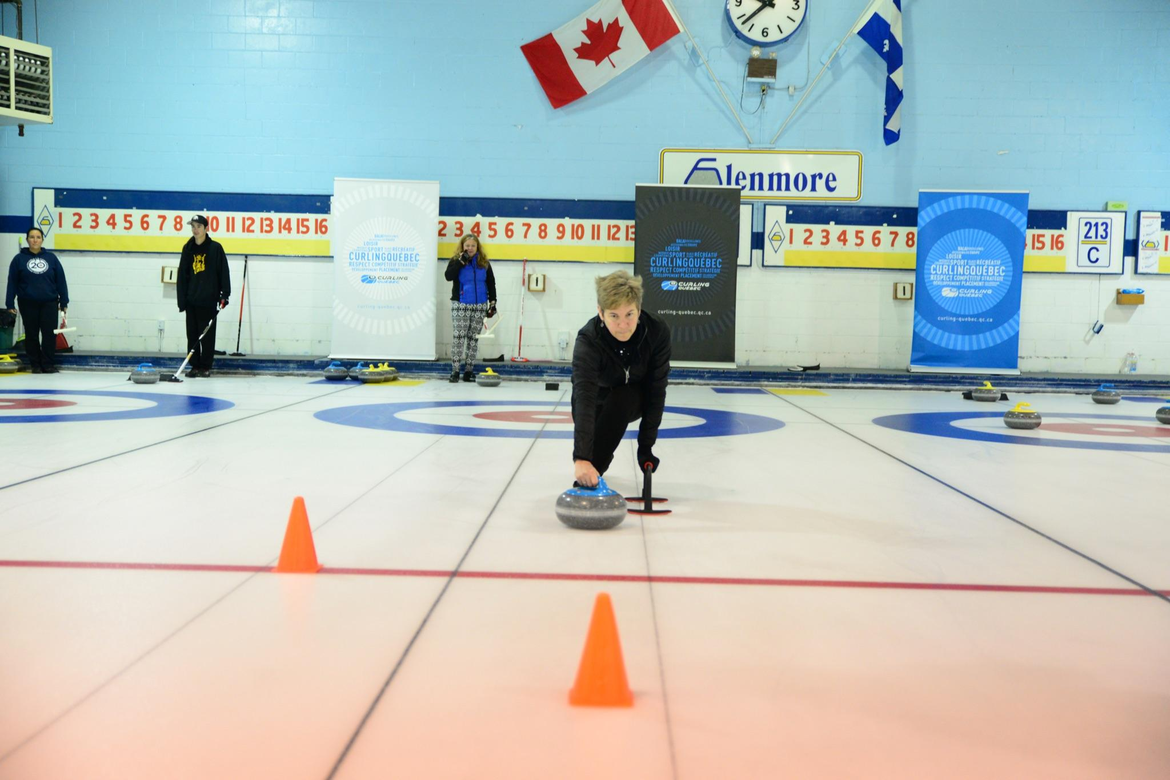
*The drills allow participants to find the right starting position which will improve their balance during the throw.

Game (0 minute)
- No game with this session

Stretching session (5 minutes)
5 minutes – Stretching session
- The instructor asks the participants to name muscle groups to stretch after curling (e.g. hamstrings, triceps, pectorals, quadriceps)
- Choose four to five stretches and hold the positions for 30 to 45 seconds each.
- The instructor directs the stretching session according to the answers given by the participants.

End of the session, thank the participants and announce the subjects that will be covered in the next session!

WEEK 4 - Holding the rock/Rock rotation/Release

Goals
- Skip’s signals
- Technique for holding the rock
- Technique for release

Off-ice session (45 minutes)
Review the points from the previous week
15 minutes - Skip’s signals
- The instructor explains the different signals that the skip will provide to indicate the rotation which should be added to the stone during the release.
- The instructor demonstrates an example with a participant (use a plastic stone, an old curling stone or a coffee cup to demonstrate the starting angle of the handle).
- Demonstrate clockwise and counter-clockwise rotation.
25 minutes – Holding the stone / Release
- The instructor explains the important points to remember when holding the stone.
- The participants squat down and position their arms to reproduce the starting position and the grip of the stone.
- The instructor explains the position of the arm, the rotational movement of the stone during the release, as well as the final position of the hand at release.
5 minutes - Warm-up sessions
- The instructor demonstrates some exercises with dynamic stretching (e.g. front lunges).
- Choose four to five exercises and perform each one for about 30 to 45 seconds.
- The instructor directs the warm-up session.

Technical session on-ice (75 minutes)
15 minutes – Practice taking the stone and performing the proper rotation
- Participants work in teams of two, face to face, positioned with one partner on each of the sidelines.
- One participant from each team takes a rock. In the squatting position, use the correct rock-holding technique and throw towards the other participant.
- The participant who does not have the rock must indicate which rotation should be thrown.
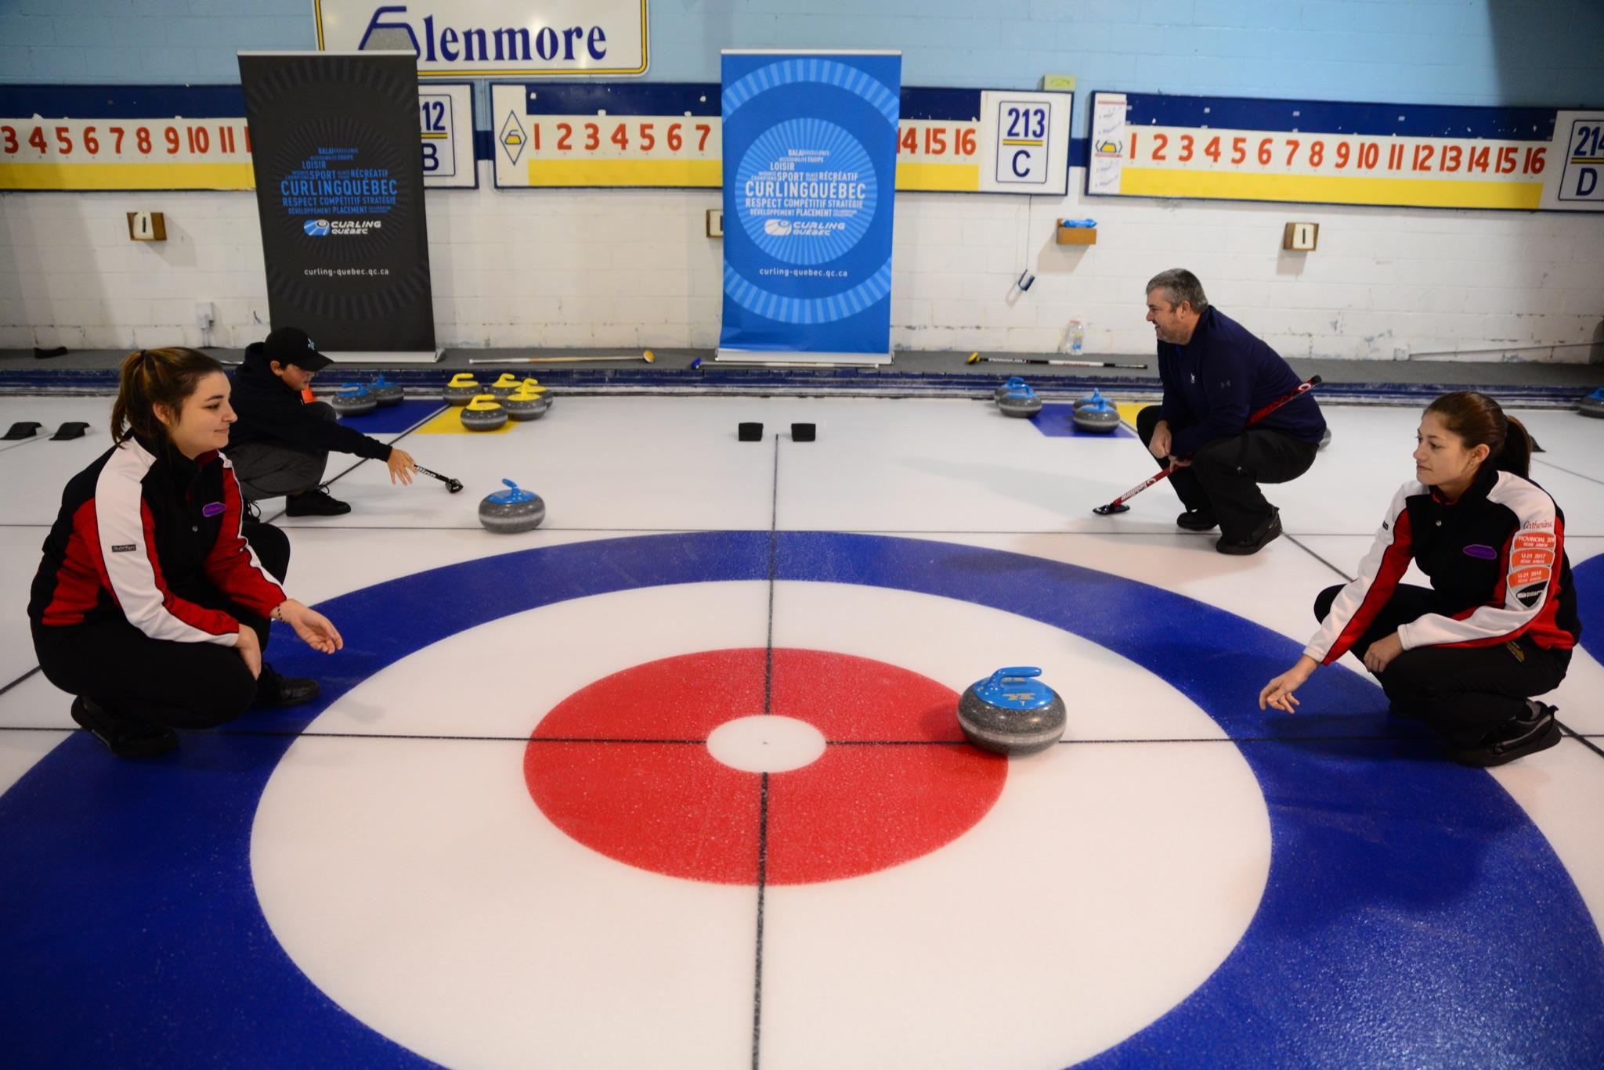
- Do this a few times using both rotations.
20 minutes – Drill #1: Practice clockwise and counter-clockwise rotation (with a stabilizer)
- The instructor installs a cone or target at the closest hog line.
- The instructor positions themselves in the hack and reminds the participants about the elements of a proper starting position and demonstrates the grip of the stone. The instructor will slide towards the target and end with the stone rotated to the 12 o’clock position (do not let go of the stone).
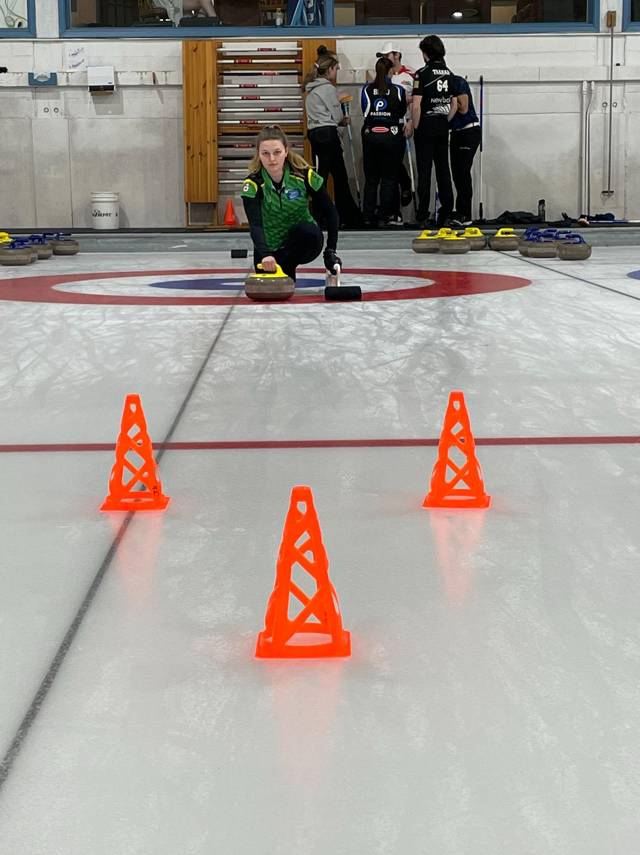
- The participants take a few slides toward the target while practicing both rotations (clockwise and counter-clockwise).
20 minutes – Drill #2: Releasing with the proper rotation
- Participants continue drill #1 but this time they will release the stone.
- Repeat a few times by practicing the two rotations and by moving the target position along the nearest hog line. The instructor stops the stones after the release.
20 minutes – Drill #3: Throw a target with the right rotation
- Progress drill #2 by adding a target in the house at the far end of the sheet.
- Participants try to integrate the starting position, gripping the rock and release.
- Repeat the drill while throwing guard and draw weight (disregard if the rocks do not reach the second hog line, the aim is to practice gripping the rock and release it with the correct rotation).

*The instructor focuses on the grip of the stone and the rotation movement of the stone when it is released.

Game (0 minute)
- No game for this session

Stretching session (5 minutes)
5 minutes – Stretching session
- The instructor asks the participants to name muscle groups to stretch after curling (e.g. hamstrings, triceps, pectorals, quadriceps)
- Choose four to five stretches and hold each position for 30 to 45 seconds.
- The instructor directs the stretching session according to the answers given by the participants.

End of the session, thank the participants and announce the subjects that will be covered in the next session!

WEEK 5 - Sweeping / Review of the slide

Goals
- Introduction of sweeping in the open position
- Footwork while sweeping
- Understanding the basic effects of sweeping
- Review of the slide and the release

Off-ice session (45 minutes)
Review the points seen in the previous week
15 minutes - The effect of sweeping
- The instructor asks participants to list the effects of sweeping.
- The instructor explains the different effects that sweeping in front of the rock has.
15 minutes – Factors that can influence the speed of stones
- The instructor asks the participants what factors could influence the speed of the stones during the game.
- The instructor explains some factors that can influence the speed and curl of a stone.
10 minutes - Basic position for sweeping in the open position
- The instructor explains and demonstrates the basic open position when sweeping.
- Participants each have a broom and get into the sweeping position facing the instructor. Try to change the position of the hands to keep an open position (being on the left side or right side of the rock).
5 minutes - Warm-up session
- The instructor emphasizes upper body warm-up for sweeping preparation.
- Choose four to five exercises and perform each one for about 30 to 45 seconds.
- The instructor conducts the warm-up session with the help of participants who can name important muscle groups used for sweeping (example: pectorals, triceps, and abdominals).

Technical session on-ice (45 minutes)
15 minutes – Drill #1: Sweeping in a line
- The instructor divides the participants into two groups. Each group stands in single file on the 4-foot line facing the distant house.
- The instructor asks the participants to begin sweeping while moving slowly together in a line towards the opposite house. Once at the other end of the sheet, the instructor asks the participants to turn their bodies towards the house where they came from and reverse the position of their hands on the brush in order to return to the opposite end while maintaining an open position. Continue the drill by sweeping the entire length of the sheet.
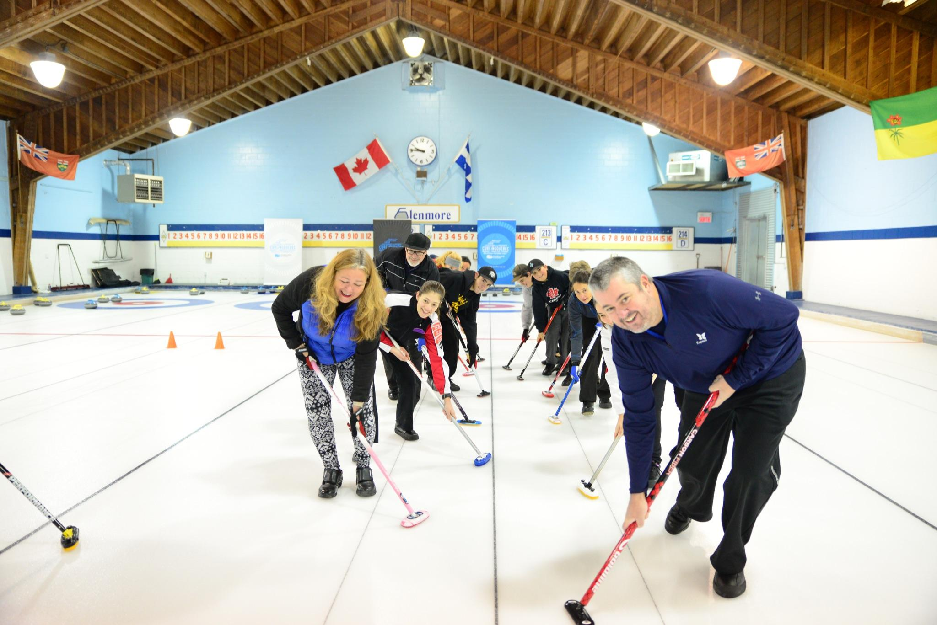
15 minutes – Drill #2: Sweeping a stone
- The participants take a few practice slides and take turns attempting to throw guards and draws. One participant will sweep each thrown stone.
- The participants review the position in the hack, the technique of sliding, and sweeping in the open position with a moving rock.
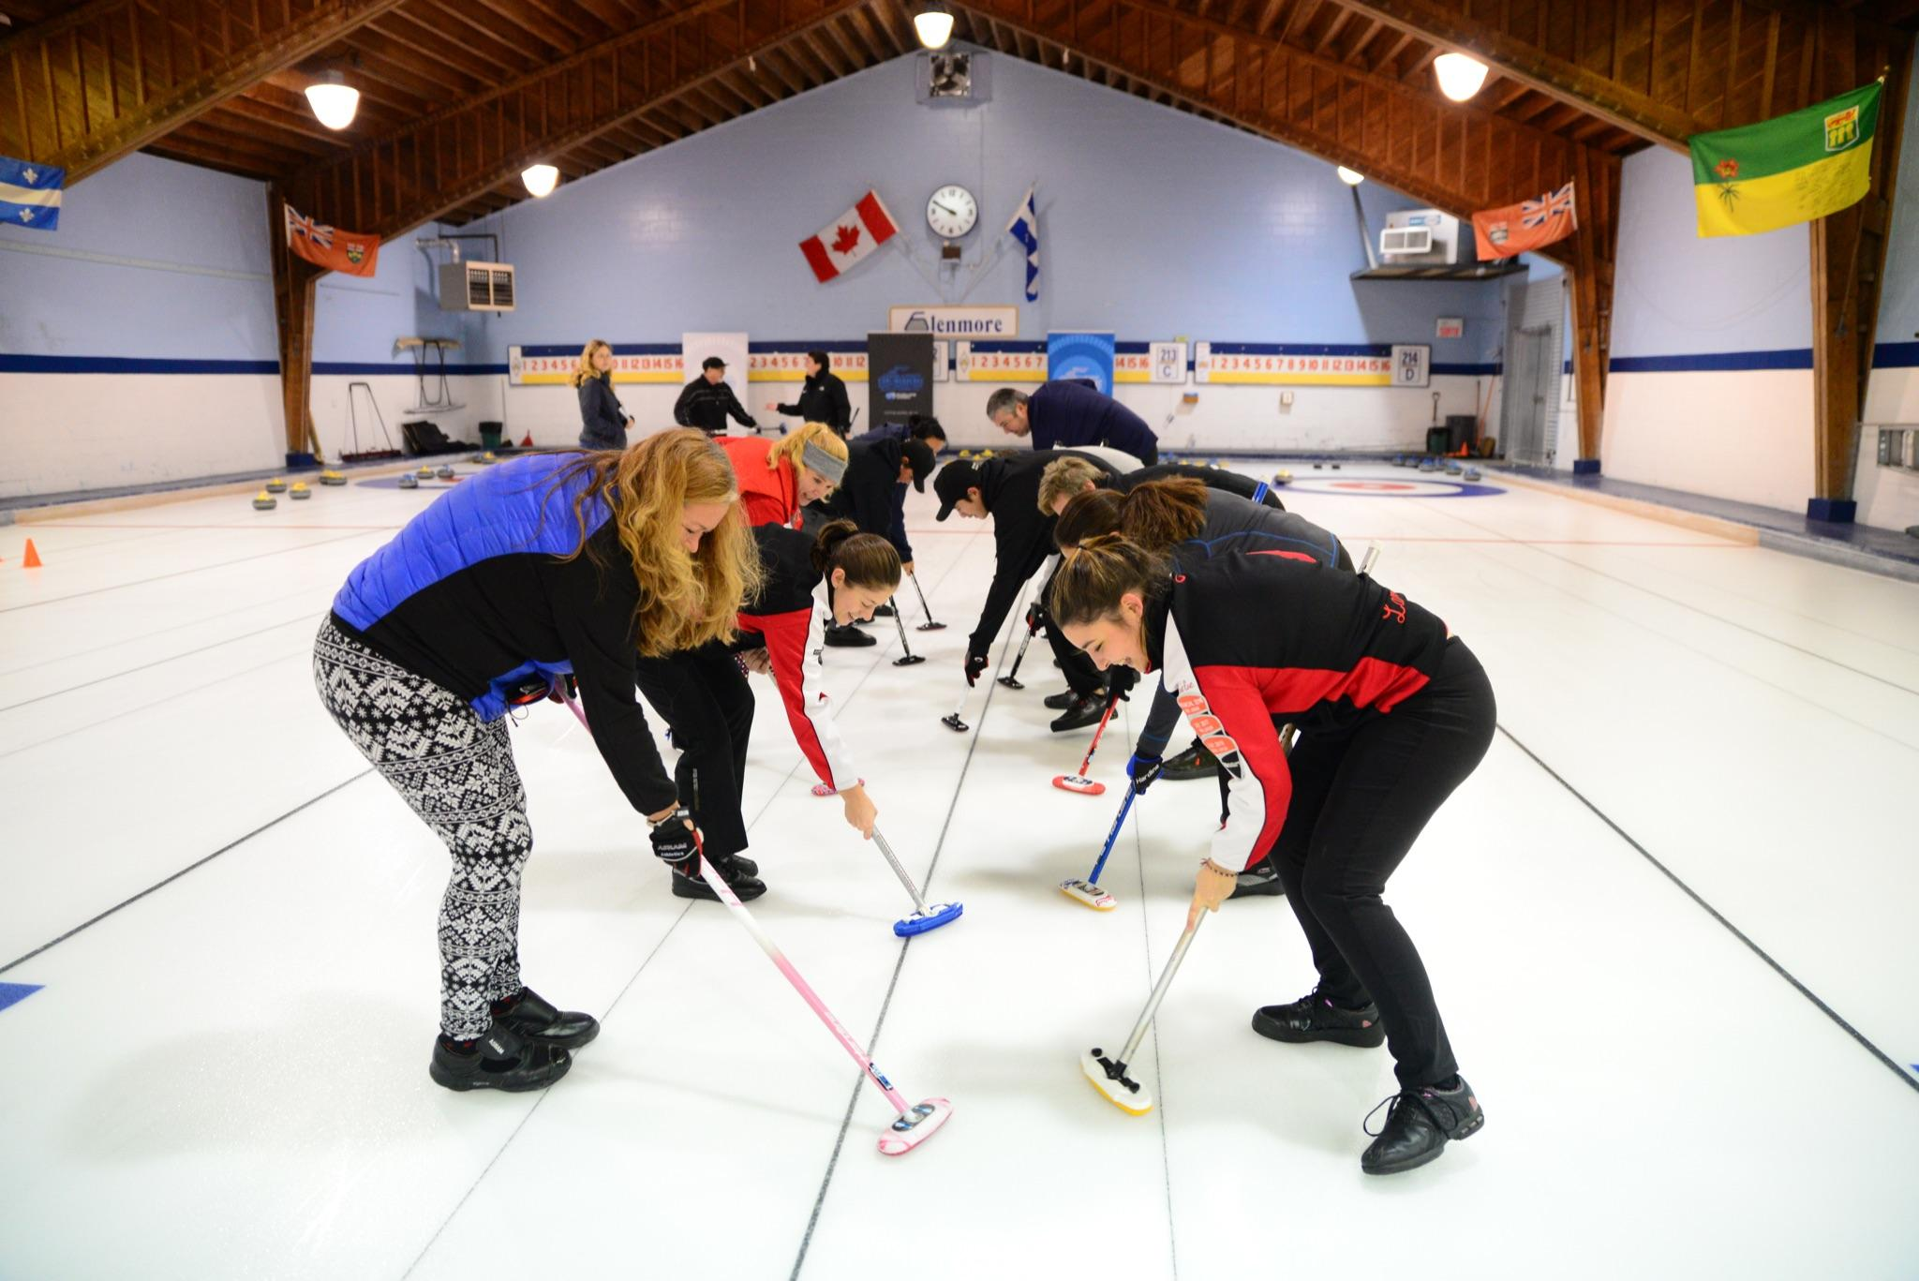
- Ensure that participants move their feet safely and wear two non-slip soles while sweeping.
15 minutes – Drill #3: Judging a stone
- The instructor introduces the judgment of rock speed. They divide the surface, from hog to back line, into four zones (zone 1 and 2 = guard, zone 3 = in the house in front of the tee-line and zone 4 = in the house behind the tee-line).
- The instructor asks the sweepers to call out a zone after each rock has been released. What is the result? Was anyone close to their call?
- This is a good way to learn to judge the weight of a thrown stone.

Game (30 minutes)
Game #1 - 2 ends
- The instructor divides the participants into two teams per sheet.
- The instructor explains how the two-end game will be played, each player will throw two rocks in a row, while alternating with the opposite team, and this is to be repeated for each end.
- The instructor helps the 2 players who have been designated as skips to place their brooms in the house in order to give a target to the throwing players.
- Ask participants to throw only guards or draws.
- At the end of each end, help participants count the points and post them on the scoreboard.
*The instructor focuses on sweeping and helps participants determine whether or not to sweep according to the requested shot.

Stretching session (5 minutes)
5 minutes - Stretching session
- The instructor asks the participants to name the muscle groups to stretch after curling (e.g. quadriceps, calves, lower back, forearms).
- Choose four to five stretches and hold each position for 30 to 45 seconds.
- Participants lead the stretching session with the supervision of the instructor.

End of the session, thank the participants and announce the subjects that will be covered in the next session!

WEEK 6 - Line of delivery

Goals
- Review the starting position in the hack
- Steps for a successful slide towards a target
- Slide with a stabilizer towards a target

Off-ice session (30 minutes)
Review the points discussed the previous week
5 minutes - Review of the position in the hack
- The instructor asks the participants to recall the important points for a proper position in the hack.
20 minutes - Line of delivery
The instructor demonstrates the elements involved in the line of delivery:
- The dominant eye, the hand holding the stone, the center of the stone and the sliding foot.

The instructor explains the different stages of the throw from the starting position in the hack:
- The position in the hack
- The back swing
- The weight transfer and forward momentum
- The push off from the hack
- The sliding position
- The release
5 minutes - Warm-up session
- The instructor asks the participants which muscle groups are important to warm up before the sport of curling.
- Choose four to five exercises and perform each one for about 30 to 45 seconds.
- The instructor directs the warm-up session according to the participants' responses.

Technical session on-ice (60 minutes)
10 minutes - Refresher of the position in the hack
- The instructor can ask a participant to demonstrate and explain the important things to remember.
- Participants each take one or two practice slides with the stabilizer (without stones).
15 minutes – Drill #1: The corridor
- The instructor places cones or tissue boxes between the hack and the nearest hog line to form a corridor, and places a target on the nearest hog line.
- Participants try to slide in a straight line towards the target without going past it and without touching the objects that form the corridor.
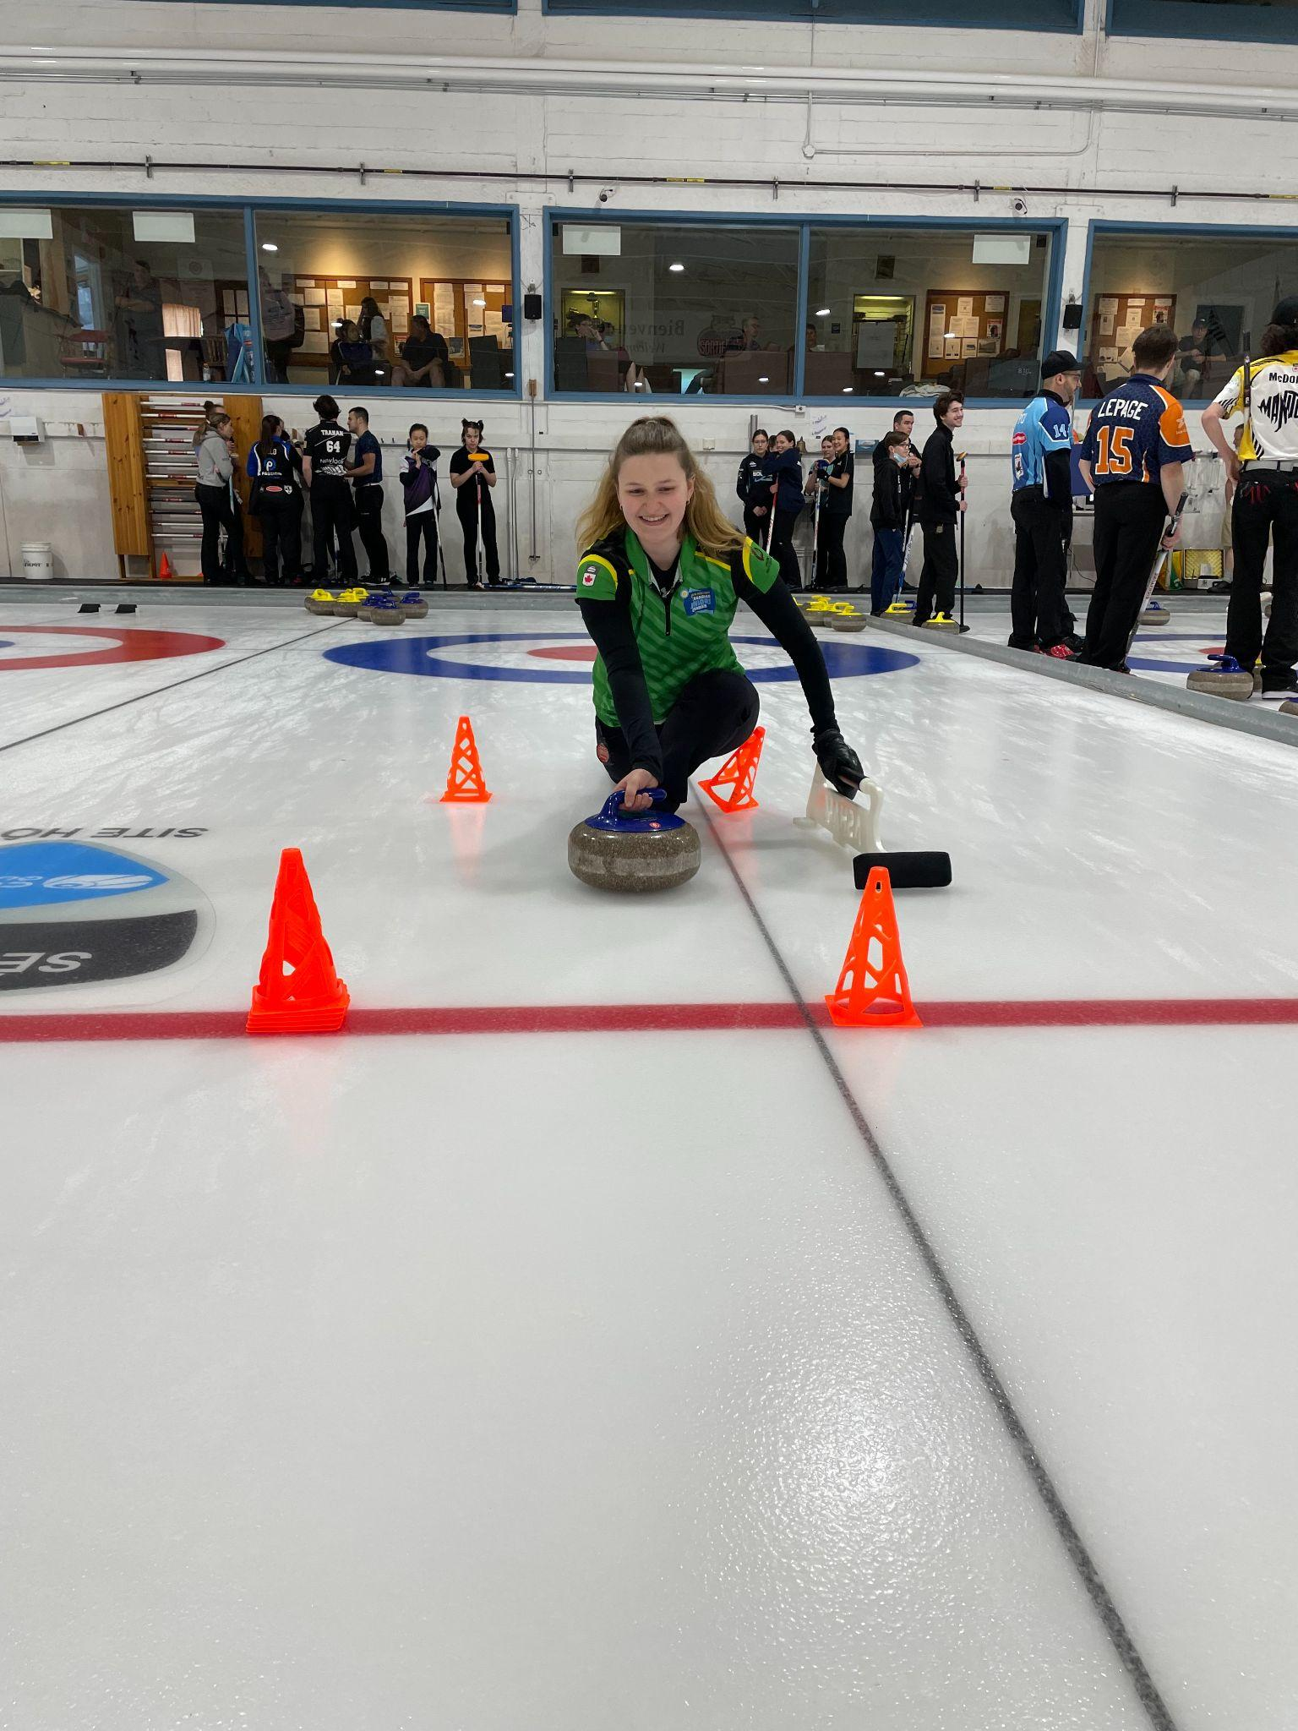
- Repeat this drill without a rock and then with a rock. The instructor may also vary the width of the corridor.
15 minutes – Drill #2: Pick up the item
- The instructor places an object at different distances along the playing surface.
- Still using the stabilizer, participants position themselves in the hack and slide towards the object to pick it up.
15 minutes - Drill #3: Aim at a distant target
- The instructor installs a broom or a cone in the house at the far end of the sheet.
- Each participant will aim for the target and will push out of the hack at similar speeds (draws and guards only). The goal is for all of the rocks to finish in the same place.
- The instructor tries to explain to the participant what may have been different in the starting position or the slide if a rock does not finish in the same place as the previous rock.
Examples: Were the shoulders parallel to the ice, did the slider foot have the heel-toe position at the start, was the body well-oriented towards the target at the start, did the participant pull their slider foot too far back in the backswing, did the participant's body rotate during the weight transfer?
*These three drills could be divided up into three stations, and the participants can change stations every 15 minutes. This requires one instructor/trainer per station.

Game (30 minutes)
Game #1 - 2 ends
- The instructor divides the participants into two teams per sheet (Ensure that the participants play different positions from the previous weeks).
- The instructor helps the skips to place their brooms as a target to the throwing players.
- Ask participants to use only guard or draw weight.
- After each end, ask the participants to count the points and post them on the scoreboard.
*The instructor focuses on each participant’s position in the hack and sliding mechanics during the game.

Stretching session (5 minutes)
5 minutes - Stretching session
- The instructor asks the participants to name muscle groups to stretch after curling (e.g. hamstrings, triceps, pectorals, quadriceps)
- Choose four to five stretches and hold the positions for 30 to 45 seconds each.
- Participants lead the stretching session with the supervision of the instructor.

End of the session, thank the participants and announce the subjects that will be covered in the next session!

WEEK 7 - Weight control/Weight judgement

Goals
- Three different types of shots
- Basic communication between the players
- Develop a sense of judgment of the speed of the rocks

Off-ice session (30 minutes)
Review the points discussed last week
10 minutes - Three types of shots
- The instructor explains the different types of shots used during a game and why they are used (guards, draws and take-outs).
15 minutes - Basic communication between players
The instructor demonstrates to the participants a division of the area from hog to back line into five zones.
Zone 1 = guard, the half closest to the hog line
Zone 2 = guard, the half closest to the house
Zone 3 = top half of the house
Zone 4 = back half of the house
Zone 5 = from the back line to the board behind the hack
The instructor explains the basic communication a team should use during a shot in regards to judging the weight of the rock.
5 minutes - Warm-up session
- If there is enough room in the curling club, create an obstacle course (pay attention to the physical abilities of your participants).
- Choose four to five exercises and perform each one for about 30 to 45 seconds.
- The instructor directs the warm-up period according to the established route.

Technical session on-ice (60 minutes)
20 minutes - Drill #1: Hit the right zone
- The instructor places cones on the edge of the sheet to delineate the five zones.
- Use a big soft die (found in dollar stores) or prepare sheets of paper with the numbers 1 to 6.
- Each participant throws the die or draws a number and must send their rock to the drawn area. If the number 6 comes out, the participant chooses the area they want to target.
- For every thrown stone, two sweepers will judge the weight and will sweep if needed.
20 minutes – Drill #2: Different game situations
- The instructor or a participant goes to the house at the far end of the sheet and calls a shot (guard, draw or light take-out).
- The person in the hack must aim for the broom while trying to release the rock with the right weight.
- The two sweepers try to judge the speed of the rock by communicating a number from 1 to 5 to the player in the house.
20 minutes – Drill #3: The Great Wall of China
- The instructor places four to six rocks in one line in the free guard zone at the far end.
- Participants learn to throw a heavier draw weight in order to raise the rocks into the house.
- Two sweepers judge the weight and sweep according to the strength of the shot.
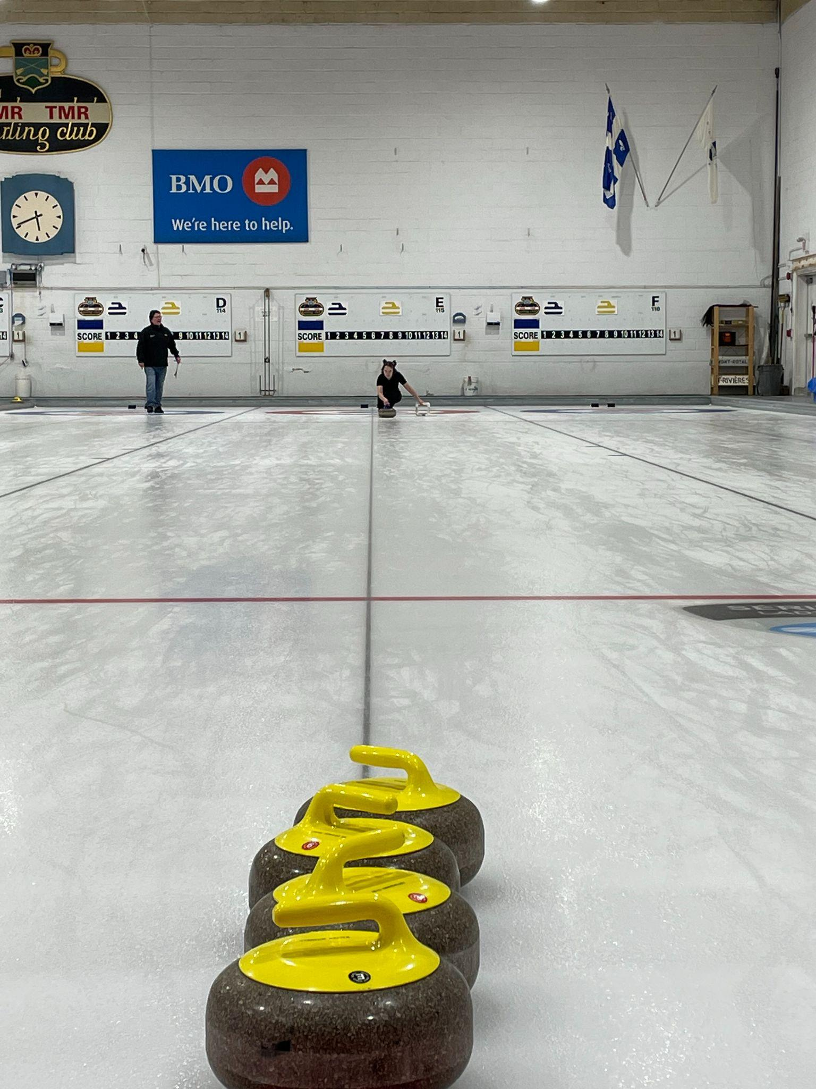
*Remember that the sweepers must have two non-slip soles (grippers) and that each of them must sweep in the open position.

Game (30 minutes)
Game #1 - 2 ends
- The instructor divides the participants into two teams per sheet (Remember to assign the participants to different positions from the previous weeks).
- The instructor helps the skips to position their brooms in order to give a target to the throwers.
- Ask the participants to use only guard, draw or light take-out weight.
- After each end, ask the participants to count the points and post them on the scoreboard.
*The instructor focuses on the communication of the weight of the rocks by the participants.

Stretching session (5 minutes)
5 minutes - Stretching session
- The instructor introduces one or two yoga positions (example: cobra or warrior position).
- Choose four to five stretches and hold each position for 30 to 45 seconds.
- The instructor directs the stretching session.

End of the session, thank the participants and announce the subjects that will be covered in the next session!

WEEK 8 - Basic notions about strategy

Goals
- Factors that can influence our choices
- Basic strategy with or without the hammer
- Which part of the play area to control

Off-ice session (30 minutes)
Review the points discussed last week
10 minutes - Factors that can influence our choice of strategy
- The instructor asks the participants what factors can influence a team's strategy choices.
- The instructor discusses the various factors with the participants.
15 minutes - Basic strategy with or without the hammer
- The instructor explains the basic strategy used with and without the hammer in a game.
5 minutes - Warm-up session
- The instructor uses a ball and throws it to one of the participants, who must either mention a warm-up benefit or demonstrate an exercise.
- Choose four to five exercises and perform each one for about 30 to 45 seconds.
- Participants lead the warm-up session under the supervision of the instructor.

Technical session on-ice (60 minutes)
10 minutes - Scenarios with the whole group
- The instructor stands in the house with a few stones and the participants stand near the instructor so that they can clearly see the demonstrations.
- The instructor demonstrates a few scenarios to the participants for situations with and without the hammer. Interact with participants to see what the next shot should be.
20 minutes – The surprise game
- The instructor and three other participants position themselves on 4 sides of the house. All four people have a rock in each hand, one of each colour. At the signal, everyone pushes their stones towards the center of the house and a surprise scenario will be created.
- The instructor gives a scenario (e.g. first end without the hammer, your team plays with the red rocks and it is your last rock to play).
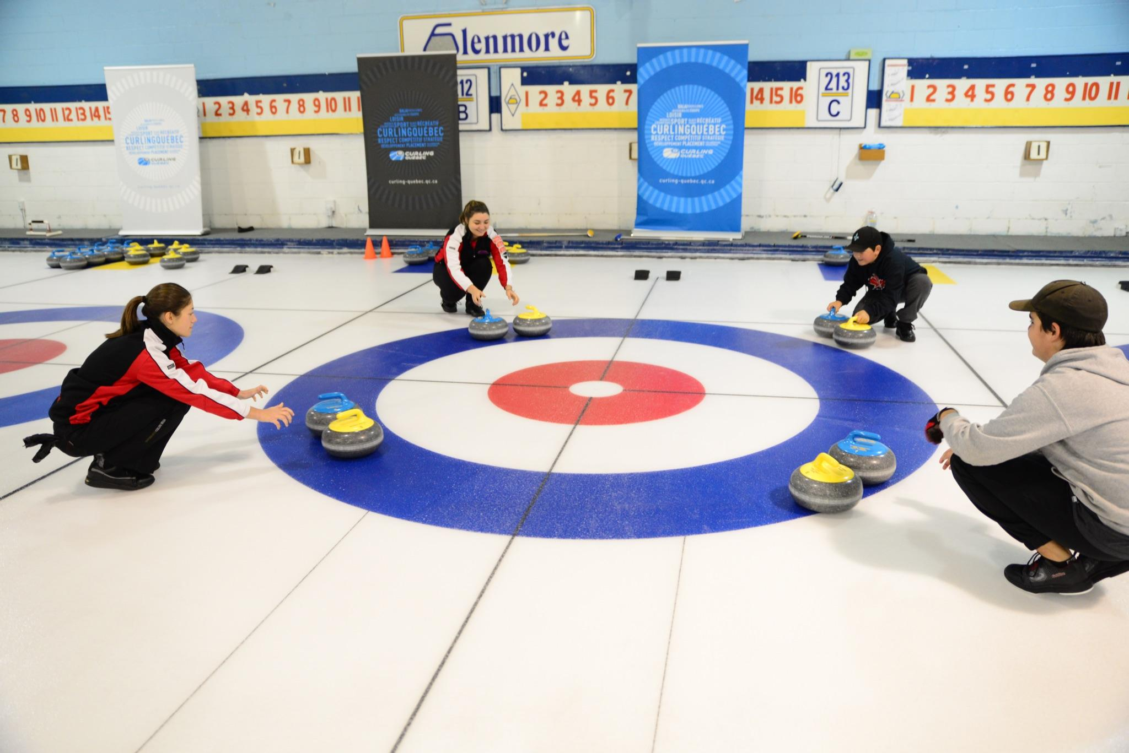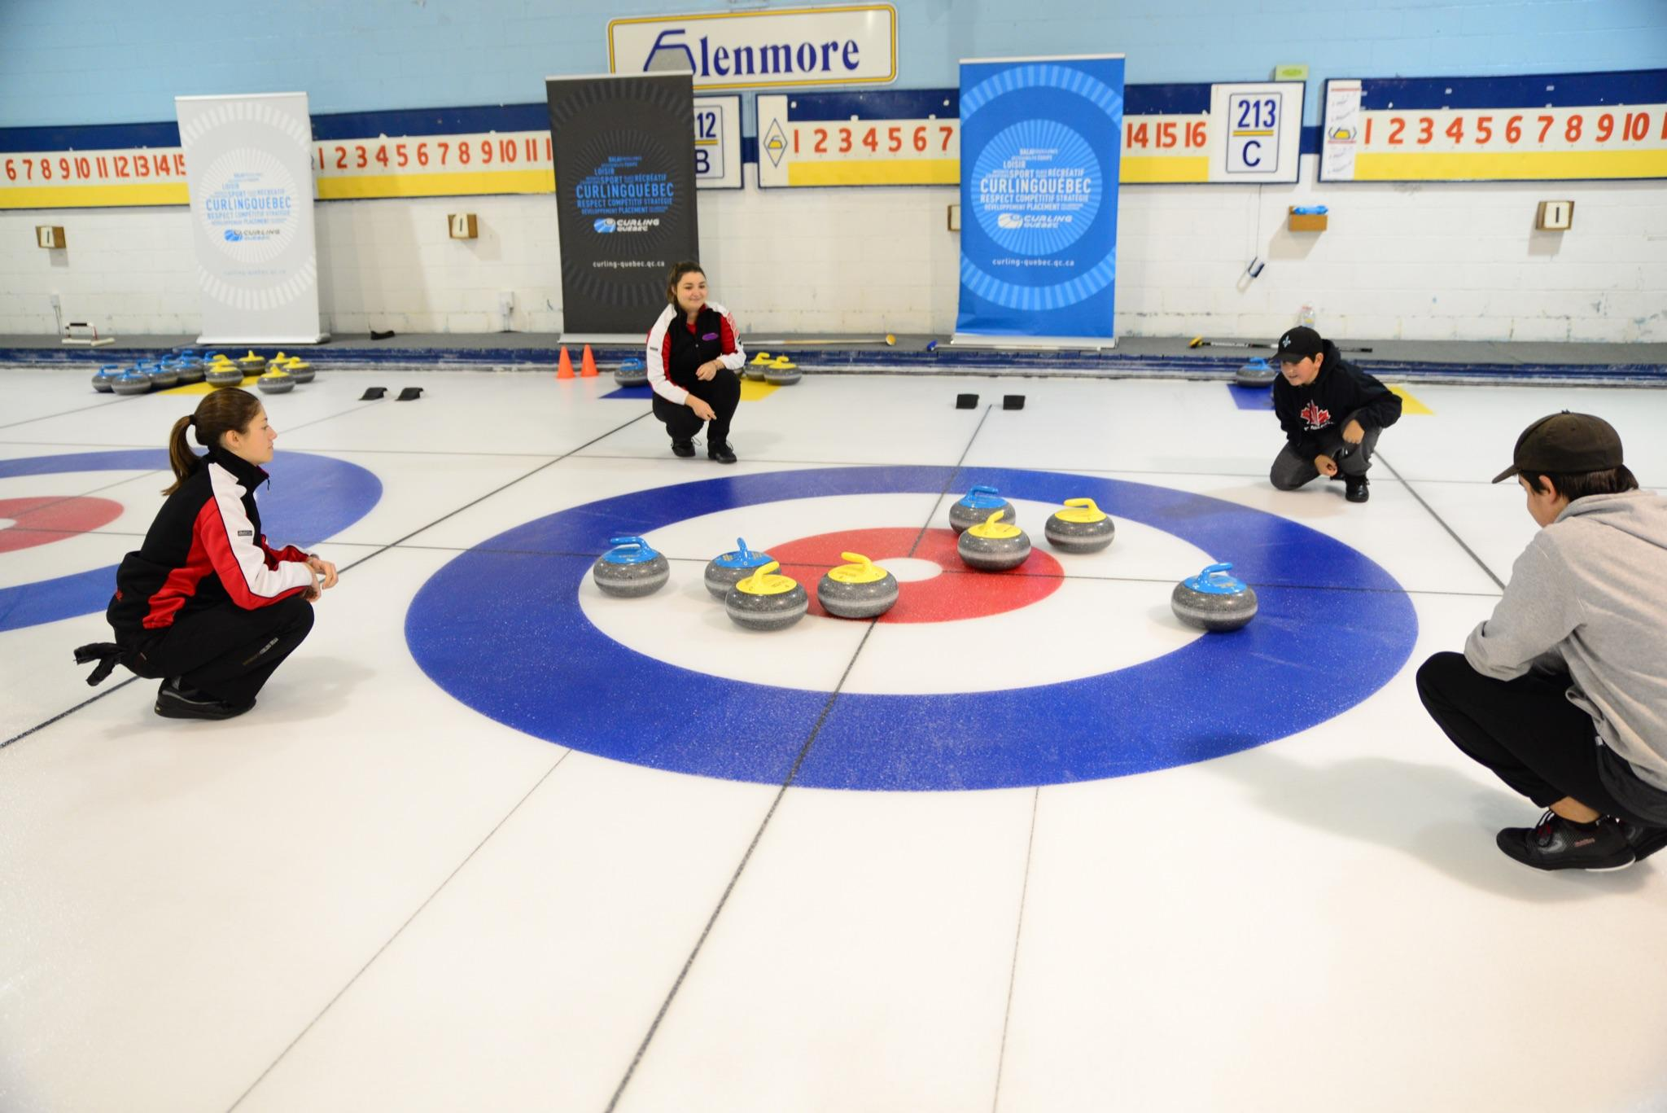
- The instructor discusses the different strategy options with the participants.
30 minutes – Simulation of two ends according to a determined score
- The instructor hangs some points on the scoreboard and gives each team an objective. Participants can therefore throw a few rocks as if they were in a game situation while working on the different elements learned so far in level 1.
- Run the drill a second time by changing the score and the game situation. The instructor helps the participants.

Game (30 minutes)
Game #1 - 2 ends
- The instructor divides the participants into two teams per sheet.
- The instructor helps the skip place their broom in order to give a target to the player in the hack and to decide on the strategy to use (with or without the hammer).
- Ask the participants to use only guard, draw or light take-out weight.
- At the end of each end, ask the participants to count the points and post them on the scoreboard.
*The instructor emphasizes the basic strategy with the participants.

Stretching session (5 minutes)
5 minutes - Stretching session
- The instructor has a ball and throws it to one of the participants who will be demonstrating a stretching exercise. Once completed, the participant throws the ball to another and so on.
- Choose four to five stretches and hold each position for 30 to 45 seconds.
- Participants lead the stretching session under the supervision of the instructor.

End of the session, thank the participants and announce the subjects that will be covered in the next session!

WEEK 9 - Introduction of the role of each player

Goals
- Roles of each player
- Communication between the players
- What to say and not to say

Off-ice session (30 minutes)
Review the points discussed last week
15 minutes - Roles of each player
- The instructor divides the participants into four groups and asks them to come up with a few roles for each position. Example: group # 1 will talk about the lead position, group #2 will talk about seconds, etc.
- Round table discussion and mention of roles that may have been forgotten.
10 minutes - Communication between players
- The instructor explains the communication that should be used during a shot and can act out a scenario with four participants who will act as the team.
- Basic communication is explained before, during and after the shot.
5 minutes - Warm-up session
- With the help of the participants, the instructor reviews the benefits of stretching and important muscle groups to warm up.
- Choose four to five exercises and perform each one for about 30 to 45 seconds.
- The instructor leads the warm-up session with the participants.

Technical session on-ice (60 minutes)
10 minutes - Practice
- Each participant takes a few slides and throws one or two rocks up and down the sheet to get an idea of the speed of the ice.
20 minutes – Drill #1: The crazy house
- The instructor divides the participants into two teams of 4 players each.
- The objective of the game is to finish with as many rocks as possible in the house.
- The winning team is the one with the most rocks in the house, and will have the advantage of the hammer for the following drill.
30 minutes – Drill #2: Simulated game with magic rocks
- Keep the same teams as in drill #1.
- The instructor creates a scenario and puts a score up on the board.
- Participants must emphasize the communication of the rock weight while reviewing all the technical points of the position in the hack, the stages of the shot, the release and sweeping in the open position.

*Instructors focus on communication between players.

Game (30 minutes)
Game #1 - 2 ends
- The instructor divides the participants into two teams per sheet.
- The monitor supervises the game and makes minor corrections to the starting position, the stages of the slide, the release and the sweeping in the open position.
- Ask the participants to use only guard, draw or light take-out weight.
- After each end, ask the participants to count the points and post them on the scoreboard.
*The instructor focuses on communication between participants for both ends.
**Ensure that participants play each position over the weekly sessions.

Stretching session (5 minutes)
5 minutes - Stretching session
- The instructor asks the participants to recall the benefits of stretching.
- Choose four to five stretches and hold each position for 30 to 45 seconds.
- Participants lead the stretching session under the supervision of the instructor.

End of the session, thank the participants and announce the subjects that will be covered in the next session!

WEEK 10 - Special Day Level 1

Goals
- Fun activities and games
- Goal review of all the points seen during level 1
- Evaluation of the 10 week program
*You can organise a snack or a meal at the end of the session. Watch out for allergies.

Off-ice session (15 minutes)
Review the points discussed last week
15 minutes - The instructor takes a few minutes to recall the progress of the participants and does a quick review of all the subjects covered in Level 1
- This session allows you to put all the points seen during Level 1 into practice.
- Remind participants to have fun.
- The instructor explains that the participants will have 40 to 45 minutes to take a few practice shots and perform two drills before the game.
5 minutes - Warm-up session
- With the help of participants, the instructor reviews the benefits of warm-ups and important muscle groups to warm up.
- Choose four to five exercises and perform each one for about 30 to 45 seconds.
- The instructor leads the warm-up session with the participants.

Technical session on-ice (45 minutes)
15 minutes - Practice
- Participants take a few slides without stones.
- Each participant throws a rock from each end of the sheet.
15 minutes – Station #1: The ball in the bucket (divide the participants into two teams)
- Install a bucket or a plastic beer cup anywhere on the sliding surface (close to the hog line).
- Participants settle into the hack with a stabilizer in one hand and a spoon in their throwing hand.
- Once the participant is in the hack, the instructor places a ball (size of your choice) on the spoon.
- Participants must slide towards the bucket while keeping their arm out in front of them.
- The team that deposits the most balls into the bucket wins the challenge.
15 minutes – Station #2: The mini-game (divide the participants into teams of four)
- Bring all the stones past the first hog line.
- Participants throw the rocks into the house from the nearest hog line.
- Participants play a mini-game but are not allowed to throw take-outs (just taps). There is no sliding involved.
- Play a mini end

Game (60 minutes)
Game #1 - 2 ends
- The instructors can let the participants form their own teams or draw spots.

Game #2 - 2 ends
- The instructors can change the teams or simply change opponents.

*We do not necessarily choose the teams according to the players’ skill levels. It is important that each participant has the chance to play at different positions.

Stretching session (5 minutes)
5 minutes - Stretching session
- With the help of the participants, the instructor reviews the muscle groups most used in curling.
- Choose four to five stretches and hold each position for 30 to 45 seconds.
- The instructor directs the stretching session according to the answers given by the participants.

End of Level 1
- Thank the participants and ask each of them to complete the evaluation of the league (or program) and take a group photo

