AFFILIATION – 2021-2022 SEASON FEES
FEES
Description | Annual fee | Annual fee  (tax included) | Deadline
Club* | 0$ this season  (usually 400$) | 0$ this season (usually $459.90) | Waived du to Covid-19
Regular curler** (Adult) | $21.74 | $25.00 | December 15, 2021
Regular curler** (Junior)  (Age 20 and under on July 1, 2021) | $11.74 | $13.50 | December 15, 2021

* Club: Any establishment that is duly incorporated as a legal person, a company or a non-profit organization, that is a member of its regional association and whose primary objective is to manage, develop and promote curling.
** Regular curler: Anyone who curls regularly at a curling club affiliated with Curling Québec.

SCHEDULE
Date | Description
December 1, 2021 | Deadline for completing the affiliation form (on paper or electronically)
December 1, 2021 | Deadline for providing the complete list of all club regular curlers  (on paper or electronically)
December 5, 2021 | Deadline for receipt of complete itemized invoice from Curling Québec (by e-mail)
December 15, 2021 | Deadline for remitting all affiliation fees for the 2021-2022 season*
* A 50% penalty shall apply for any payments made after December 15.

ACCEPTED PAYMENT METHODS
- Interac e-transfer (info@curling-quebec.qc.ca). Enter the details in the Note or Message space provided by your financial institution.
- Bank transfer (see Curling Québec’s banking information on the void cheque, below).
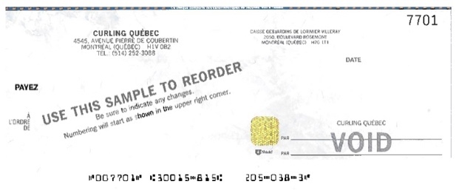
- Cheque (the postmark serves as proof of the payment date).

